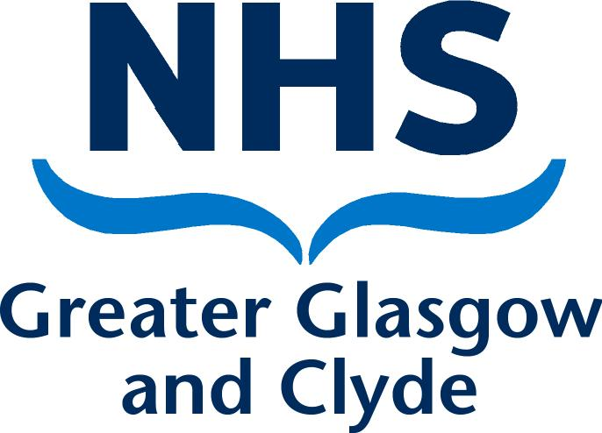

Local Dispute Resolution Procedure
under the new GMS Contract

January 2009

Background

  - With the implementation of the new GMS Contract on 1 April 2004 NHS Boards are required to have in place a local dispute resolution procedure. This procedure is designed to resolve issues that arise within the new GMS Contract given the expectation that most contractual disputes can be resolved as part of the normal contractual relationship.

  - The National Health Service (General Medical Services Contracts) (Scotland) Regulations 2004 (Part 7, paragraphs 90-92) outlines the formal NHS dispute resolution procedure which is initiated by referral of the dispute for consideration and determination to Scottish Ministers.

  - The procedure in this document describes the local resolution of disputes arising out of or in connection with the GMS Contract for example, a dispute as to whether a contract provision has been properly performed by the NHS Board or contractor (Practice), or a dispute concerning financial entitlement under the contract. Its aim is to ensure that every reasonable effort is made to resolve disputes locally through communication, co-operation and the use of appropriately qualified advisors before the matter is referred to Scottish Ministers in accordance with the NHS dispute resolution procedure or, where applicable, before commencing court proceedings.

  - The local dispute resolution procedure draws on the guidance in 'Implementing the new GMS contract in Scotland' issued by the Scottish Executive Health Department, specifically Chapter 6, paragraphs 6.32 to 6.36.

Scope

  - The local procedure covers disputes arising from, or in connection with, GMS contractual arrangements between NHS Greater Glasgow & Clyde and primary care contractors (Practices) except:
- matters dealt with under the NHS Complaints Procedure as defined in regulations;
- matters relating to performance (suitability, efficiency or probity) of individual doctors;
- matters relating to the Performers List;
- disputes in relation to list closures, decisions to opt out of additional services or OOH provision (these disputes are dealt with using the Assessment Panels procedure).

Local Dispute Resolution Procedure

  - When a dispute arises initial attempts should be made to resolve the matter through communication between the parties concerned. This should involve, at least in part, face to face dialogue aimed at clarifying the issues leading to dispute and ensuring that the parties involved have a clear understanding of each others position.

  - If the dispute is not resolved through direct dialogue between the parties consideration should be given to the involvement of a third party who should be acceptable to all. The general principle here is that the individual(s) being independent of the parties involved and using their experience, knowledge or skills might be able to move the dispute forward towards a resolution. In effect the third party could be anyone meeting the above criteria, e.g. a Senior Manager of a CH(C)P, a member of the GP Sub-Committee or GP representative of the Local Medical Committee. Any third party will not have a management or membership link to the CH(C)P of the practice in dispute.

  - Steps 3.1 and 3.2 should be concluded within 4 weeks from the date the dispute arises.

  - If attempts to resolve the dispute through steps 3.1 and 3.2 are unsuccessful the aggrieved party should immediately notify NHS Greater Glasgow and Clyde of the dispute in writing.

  - NHS Greater Glasgow and Clyde will acknowledge the notification and will inform the other party or parties involved in the dispute.

  - NHS Greater Glasgow and Clyde will convene a local dispute panel and refer the dispute to the panel.

  - The parties involved in the dispute will submit written information relevant to the dispute to the panel.

  - The panel will meet to consider the information provided and thereafter interview representatives of the parties involved in the dispute through the mechanism of an oral hearing, if required.

  - Following the dispute panel’s deliberation both parties will be notified of the panel’s determination in writing.

  - The dispute panel element of the process (points 3.4 to 3.9 inclusive) should be concluded within 6 weeks of the NHS Greater Glasgow and Clyde receiving notification of the dispute. Note: If a dispute remains unresolved after being deliberated by the panel, no appeal to the Board of NHS Greater Glasgow and Clyde will be permitted under this procedure, and clauses 5.1 and 5.2 of the procedure, as appropriate, will apply.

4. Flowchart outlining the Local Dispute Resolution Procedure under the new GMS
Contract

  - The flowchart shown at Appendix 1 outlines the local dispute resolution procedure
under the new GMS contract.

5. Formal Dispute Resolution Procedure

5.1 If a dispute remains unresolved following the local dispute resolution procedure
either party may refer the matter for consideration and determination to Scottish
Ministers. In such cases the NHS dispute resolution procedure applies as set out
in paragraphs 90 - 92 of the National Health Service (General Medical Services
Contracts) (Scotland) Regulations 2004.

5.2 For disputes where the contractor is not a NHS body the dispute can be referred
to either Scottish Ministers or a competent court.

 |  | Flowchart Describing the Local Dispute Resolution Procedure under the new GMS Contract |  |  |  |  | Appendix 1
 | Initial attempts made to resolve dispute between parties through dialogue - if not resolved consideration should be given to the involvement of a third party to assist efforts to resolve the dispute, e.g. GGC CH(C)P General Manager, GP Sub Committee member, GP Representative of LMC (see note) | Dispute Arises
4 WEEKS
 |  | Dispute  Resolved |  |  | End
 |  |  |  |  | YES
Aggrieved party will notify GGC Board of dispute in writing.  GGC Board will acknowledge notification and inform the other party or parties involved in the dispute, and convene a local dispute panel to resolve the dispute. The panel to comprise of:  - GGC CH(C)P Director (see note)  - GGC LMC GP member (see note)  - Paid consultant or lay person (see note) |  |  | NO
6 WEEKS
Formal Dispute Resolution to SGHD
 |  |  | Dispute Resolved |  |  | End
 |  |  | NO |  |  | YES
Note: Third parties involved and dispute panel members will not have
a management or membership link to the CH(C)P of the practice in dispute.

