Directorate for Chief Medical Officer  Dr Gregor Smith  Interim Chief Medical Officer  St Andrews House | Regent Road | Edinburgh | EH1 3DG | 

[Patient Name
Patient address Line 1
Patient address Line 2
Patient address Line 3]
4 December 2020

IMPORTANT: PERSONAL

Your Community Health Index (CHI) number: [CHI NUMBER]

BALANCING THE RISK OF DAILY ACTIVITIES BOOKLET
Dear [Patient],
I’m writing to you to share a new booklet for people who are at highest risk should they contract coronavirus (COVID-19). The booklet aims to give advice and support to help you think about how best to approach your everyday activities, while at the same time taking protective steps against coronavirus.
The booklet was developed with people like you, as well as medical professionals and organisations which support those at highest risk. It includes guidance on how to make things like work, shopping and healthcare as safe as possible, as well as sources of support. As we said in our letter to you of 23 October, we are not asking you to go back into full shielding, but you should follow the advice for your local protection level. There is also optional extra advice for those at highest risk. We sent this to you with our last letter, and you can also find it in this booklet.
Buying food and the things you need
The rest of this letter has information about buying food and the things you need. It includes how to get priority access to online supermarket delivery slots if you don’t already have it, and advice on shopping safely in person.

If your area is in level 4, you may have already received this information with your last CMO letter.
Yours sincerely,
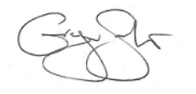

DR GREGOR SMITH
INTERIM CHIEF MEDICAL OFFICER

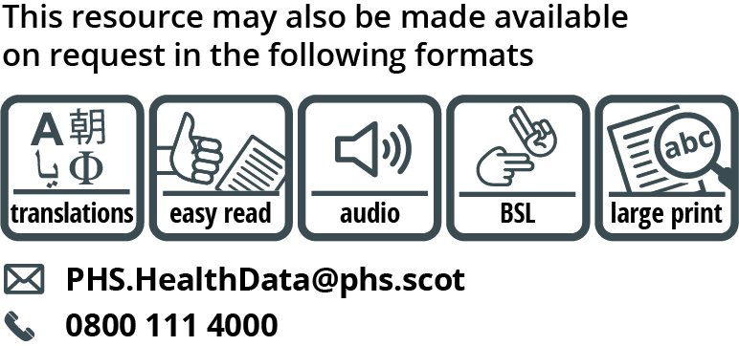

Use the subject line ‘translation request’ if you send an email. Include these details about the person who needs the different format:

- name
- address and postcode
- CHI number
- format or language required

Please also tell us if we should send information in this format in future.

If you’ve already asked for the information we send to you to be translated, it is on its way to you.

Buying food and the things you need
If you’ve already signed up for priority online shopping,
you do not need to register again

Priority access to supermarket online delivery slots

If you, your child or someone you care for is on the shielding list and you haven’t registered for a priority slot, you can sign up now. The supermarkets that offer this service are Asda, Tesco, Morrisons, Sainsbury’s, Iceland and Waitrose.

If you sign up for the service, we’ll pass your details to these supermarkets to allow them to add you to their priority booking list. Whilst this doesn’t guarantee you a slot, which will be dependent on availability, it will give you access to view booking slots further in advance.

Registering for a priority online delivery slot using our text message service

If you have not registered for priority access before, you can register now. If you are a parent or guardian of a child on the shielding list you’ll need to register using the child’s name. If you are a carer, use the name of the person you care for.

- If you are already on the Scottish Government Shielding text messaging service, sign up by texting 1SHOP to 07860 064525 from your mobile.
- If you are not on our text messaging service, join by sending a text from your mobile with your Community Health Index (CHI) number to 07860 064525. Your CHI number is the 10-digit number shown at the top of this letter.
- After you have done this, text 1SHOP to 07860 064525 to sign up for your priority online delivery slot.

If you are already an online customer with Asda, Tesco, Morrisons, Sainsbury’s, Iceland or Waitrose

- Your supermarket will email you to let you know how to access the delivery service if they are able to match your details with the information we share with them.
- They will send an email to the account you have registered with. If you don’t receive a reply, check that the email address you have registered with is still correct or check your junk mail folder.
If you are new to online supermarket shopping
- Once you have registered with our service, you will get texts from GOV.SCOT about the supermarkets that provide online deliveries in your area. The texts will explain how to sign up for these.

We can’t guarantee that you will get a slot with your supermarket of choice or that you will always get your preferred slot. What supermarkets are offering is priority access to their booking systems so that you can see slots further in advance. It may take 2-3 weeks for you to get a slot once you have registered. We will pass your information to the supermarkets. To be included this month please register by 10 December. As some supermarkets have already opened their online bookings for the Christmas period, in addition to registering for priority access, you may wish to check now whether you can book an online delivery service with your chosen retailer for December.

How to register for an online priority slot by phone
Please call the free national helpline number on 0800 111 4000 (Monday – Friday business hours). A friend or carer can call for you if you cannot call yourself.

Shopping by phone
Morrisons and Sainsbury’s offer the option to order groceries by phone.

To place an order with Morrison’s, phone 0345 611 6111 and select option 5.
Morrisons will deliver groceries from a menu of 47 essential items.

Details of how to place an order by phone with Sainsbury’s will be sent to you by email if you choose to register with them for priority access.

Alternatively, you can contact the National Helpline which will provide you with details of Sainsbury’s priority line for customers.
Shopping in person

If you go to the shops, or if someone goes to the shops for you, make getting your shopping safer by:

- reducing the number of times you go shopping
- going to the shops at quieter times
- putting on your face covering before touching baskets or trolleys
- cleaning the handles of your trolley or basket before you use them
- using hand sanitiser when you arrive and leave
- avoiding touching doors with your hands
- using contactless payment if you can

Supermarkets and shops are making shopping safer

Most shops now have areas where you can clean your hands, trolleys and baskets. There are safety screens at check outs and more self-service and contactless options. Many shops have priority hours for customers who need more help. They have also increased the ways someone else can shop for you.

Getting organised

The weeks in the run up to Christmas are a busy time of year. If you are able to, try to shop early to make sure that you have what you need over this time.

If you need more information or support to get food and other essentials

You or the person who cares for you can call the free national helpline number on 0800 111 4000 (Monday – Friday business hours).This will connect you to your local authority.

Further information
For more information about buying food and shopping safely please visit: www.mygov.scot/shielding

