Covid19 Vaccination update for GP practices – 16 December 2020

Following the communications issued on Monday and Tuesday of this week about priorities for staff vaccination, we are aware that a number of practices and individual GPs have raised queries about the process. This communication seeks to clarify some of those issues.

All patient facing NHS staff, including GPs and practice staff, are in the first priority group for vaccination in line with the CMO letter of 4th December.

Across NHSGGC there are over 55,000 people working in NHS, older adult care home and contractor services and over 6000 older adults in care homes. Therefore further prioritisation is required to ensure that those working in areas with the most exposure to COVID-19, with the most at risk patients, or with the highest risk as individuals, are vaccinated first. The precise number of slots available depends on the volume of vaccine delivered each day and is a rapidly moving picture. Sufficient vaccine also has to be retained for second doses. However, all patient facing staff and contractors will be vaccinated as soon as possible. GPs and practice staff outside the initial priority groups are being treated equally to patient facing staff in other acute and community settings. The priority groups were agreed in discussion with the Area Clinical Forum, which includes LMC representation.

Those working in the Community Assessment Centres and GP Out of Hours (who provide COVID assessments overnight, at weekends and at home visits) will be contacted by those services if they have not been already, to arrange vaccination appointments. Practices have now been provided with the link to book in any staff (patient facing or not) who are over 65, at high risk (shielding, or patient facing staff currently unable to see patients face to face due to risk) or from a Black or Minority Ethnic group. Arrangements are being made for sessional GPs in those categories to access their vaccination where they cannot be booked in by a practice.

While it is not possible to give definitive timescales for when all staff will be vaccinated and when the booking will be opened up further to GPs and practice staff out with the priority groups, the intention is that all patient facing staff will be offered the vaccine within the next few weeks, into January. Where practices are delivering vaccination to over 80s in January, a further back stop is the potential for peer vaccination. This would happen in those practices with available vaccine supplies. Further information about this will be provided when there is more detail available about the vaccine distribution arrangement.

We are also aware that some concerns have been raised that the booking link has been shared beyond those who were sent it to book in as individuals. We would ask practices not to share the link further and for everyone to take responsibility to only book in in line with the priority categories. This message is being reinforced across all services. Where any short notice slots are available and are filled to avoid any risk of wasted appointments of vaccine, again every effort is made to ensure this is in line with agreed priorities.

This is a fast moving and frequently changing situation and we appreciate the significant interest and desire for information. We will provide updates as soon as we are able to.

Information is also being updated regularly on the Board’s website, including an FAQ about COVID vaccination. This can be accessed at https://www.nhsggc.org.uk/your-health/health-issues/covid-19-coronavirus/for-primary-care-contractors/covid-19-vaccination-programme/

Yours sincerely

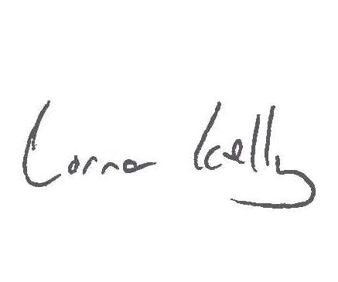 | 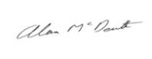
Lorna Kelly  Interim Director of Primary Care,  NHSGGC | Alan McDevitt  Chair, Glasgow Local Medical Committee

