|  |  |
| --- | --- |
| Directorate for Chief Medical Officer  Dr Gregor Smith  Chief Medical Officer  St Andrews House | Regent Road | Edinburgh | EH1 3DG |  |

xx April 2021

**IMPORTANT: PERSONAL**

**Your Community Health Index (CHI) number: <<CHI>>**

**Vaccinations for your adult household contacts**

Dear XXXXX,

I’m writing to let you know that we are now inviting your adult household contacts to come forward for their COVID-19 vaccination.

By ‘adult household contacts’ we mean people aged 16 and over who you expect to share living accommodation with on most days and who you therefore cannot avoid close contact with. Vaccinating these adults is an additional level of protection which will help reduce the risk of coronavirus being passed on to you.

Some of your adult household contacts may already have been vaccinated, or have received an appointment letter, due to their age, underlying health conditions or because they are a registered carer. We are now offering vaccination to those adult household contacts who are yet to be vaccinated or have not yet received an appointment.

There’s no time limit on taking up this offer. However, the sooner your adult household contacts register to be vaccinated, the sooner there will be an additional level of protection for you.

Yours sincerely,

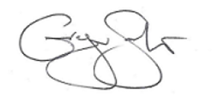

**DR GREGOR SMITH**

CHIEF MEDICAL OFFICER

**Registering for a Vaccine Appointment**

If your adult household contact lives with you, and has not been vaccinated, or received an invite for vaccination, please ask them to call the National COVID-19 Vaccination Helpline on 0800 030 8013 (daily, 8am – 8pm) to register for a vaccine appointment.

If your adult household contact does not live with you, but they share your living accommodation with you on most days, and has not yet been vaccinated or received an invite - please ask them to call the National COVID-19 Vaccination Helpline on 0800 030 8013 (daily, 8am – 8pm) to register for a vaccine appointment.

**______________________________________________________________________________**

**Taking part in research about the shielding service**

If you would like us to tell you about future opportunities to take part in surveys or research about Scottish Government’s shielding service, you can sign up here: [www.mygov.scot/shielding](http://www.mygov.scot/shielding)

**______________________________________________________________________________**

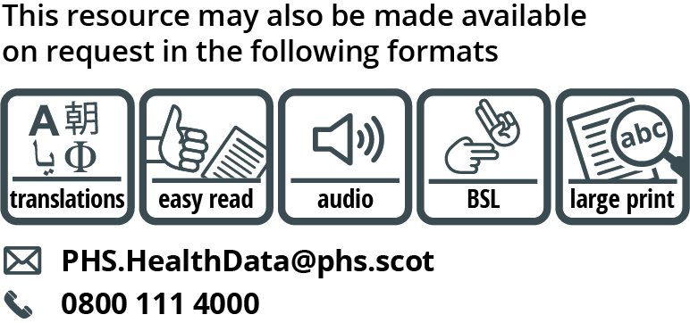

Use the subject line ‘translation request’ if you send an email. Include these details about the person who needs the different format:

* name
* address and postcode
* CHI number
* format or language required

Please tell us if we should always send information in this format. If you’ve asked before for translations of the information we send, it’s on its way to you. Find translations and other formats for past shielding letters at [www.gov.scot/shielding-letters](http://www.gov.scot/shielding-letters)