|  |  |
| --- | --- |
| Directorate for Chief Medical Officer  Dr Gregor Smith  Chief Medical Officer  St Andrews House | Regent Road | Edinburgh | EH1 3DG |  |

xx April 2021

**IMPORTANT: PERSONAL**

**Your Community Health Index (CHI) number: <<CHI>>**

**At-home coronavirus (COVID-19) tests**

**for adults who live with you**

Dear XXXXX,

I’m writing to let you know that adults in your household can now order free lateral flow tests, and to confirm that as we are moving to Level 3, you can return to work or education.

**Free lateral flow tests for adults who live with you**

Lateral flow tests are at-home coronavirus tests that give quick results. These tests are only for people who do **not** have coronavirus symptoms.

Everyone in Scotland can now get free home-testing lateral flow tests to take twice a week. This will help to find people who don’t have symptoms and would not know they have coronavirus.

If adult members of your family or household get a positive test, this could reduce the risk of them passing on coronavirus to you as they will then know to self-isolate away from you.

**How to get lateral flow tests**

You can order free lateral flow tests for adults in your household at [www.gov.scot/covidtestshielding](http://www.gov.scot/covidtestshielding) or by phoning the National Testing Centre on 0300 303 2713.

On the website, follow the instructions under ‘Order coronavirus (COVID-19) rapid lateral flow tests’. A pack of 7 lateral flow tests will then be sent to your home within 1 to 2 days. You can re-order when you need more tests. If the system reaches its daily maximum capacity you can just order the next day. Results of the tests should be reported, whether positive, negative or void. There is more information about lateral flow tests attached with this letter.

You may also be able to get lateral flow tests from some local or regional community testing centres. [www.gov.scot/covidtestshielding](http://www.gov.scot/covidtestshielding) will soon have more information about this.

Lateral flow tests are already available in some workplaces (for example, in health and social care and schools). We recommend them only for people aged 12 or over. Secondary school pupils can already access them at school.

**Continuing to follow the public health advice**

Although lateral flow tests help to identify coronavirus, they do not prevent coronavirus or replace other safety steps such as physical distancing, face coverings, hand washing, and making sure areas have lots of air circulating around. Please continue to follow the public health guidance, even if you’ve had one or both doses of the vaccination.

**Returning to work, education and formal childcare from 26 April**

Finally, from 26 April, people on the shielding list will be able to return to the workplace if they cannot work from home. They can also go to school, college, university and formal childcare. This is because, from this date, all areas are moving down to Level 3 or lower.

There is now some additional guidance at [www.gov.scot/shielding-work-safety](http://www.gov.scot/shielding-work-safety) about how to keep yourself safe at work.

Yours sincerely,

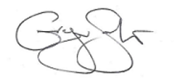

**DR GREGOR SMITH**

CHIEF MEDICAL OFFICER

**Additional Information**

**Using lateral flow tests**

These tests involve taking a sample from your nose and tonsils (or where your tonsils would have been) using a swab. The result will be ready 30 minutes later. You do not need to go to a testing centre and will get this result quickly at home.

**What to do if someone you live with tests positive using an at-home lateral flow test**

Positive lateral flow test results need to be followed up and confirmed by a PCR test. If someone you live with gets a positive result from a lateral flow test, they must enter their result online, following the instructions that come with the test. They should immediately self-isolate from you and the rest of your household. Find information on self-isolation at [www.nhsinform.scot/isolation](http://www.nhsinform.scot/isolation)

You and the rest of your household will also need to isolate, separately from the person who has tested positive.

They will be contacted by a contact tracer with further information and advice.

The person who has tested positive should book a PCR test which will be sent to a laboratory to confirm their result. This means that that if your family or household member has tested positive through a lateral flow test, they and you can start to isolate immediately to reduce the risk of transmission occurring.

If the PCR test is negative, your local health protection team will get in touch to assess whether you can all safely stop isolating.

**If you or someone who lives with you has coronavirus symptoms**

Lateral flow tests are for people who are asymptomatic (meaning they do not have symptoms). If you or anyone you live with develops coronavirus symptoms, you must book a PCR test at a testing centre which then gets sent to a laboratory for results. You can book a PCR test at [www.gov.uk/get-coronavirus-test](http://www.gov.uk/get-coronavirus-test) or by phoning the National Testing Centre on 0300 303 2713.

**People who have had a positive PCR test in the last 90 days**

People who have had a positive test result from a PCR test (a coronavirus test at a testing centre) in the last 90 days should not use lateral flow tests. If they develop symptoms again within 90 days of their last positive result, they should book another PCR test.

**Support with accommodation, food and essentials**

Your local council can help you or the people you live with to find somewhere to stay so you can self-isolate, if needed. They can also help you access food, medicine deliveries and other support.

You can contact your local council directly, or through the National Assistance Helpline on 0800 111 4000 (Monday to Friday, 9am – 5pm).

**Self-isolation Support Grant and other financial support**

If you’re unable to work from home and have a low income, you may be entitled to financial support, such as the Self-isolation Support Grant. This depends on your circumstances. You can find out more at [www.mygov.scot/self-isolation-grant](http://www.mygov.scot/self-isolation-grant) or by contacting the National Assistance Helpline on 0800 111 4000 (Monday to Friday, 9am – 5pm).

**Telling your employer you need to self-isolate**

The NHS can give you a letter stating you must self-isolate. You can show this to your employer if needed. Visit [111.nhs.uk/isolation-note](https://111.nhs.uk/isolation-note) or phone the National Assistance Helpline on 0800 111 4000 (Monday to Friday, 9am – 5pm) to find out more.

**______________________________________________________________________________**

**Taking part in research about the shielding service**

If you would like us to tell you about future opportunities to take part in surveys or research about Scottish Government’s shielding service, you can sign up here: [www.mygov.scot/shielding](http://www.mygov.scot/shielding)

**______________________________________________________________________________**

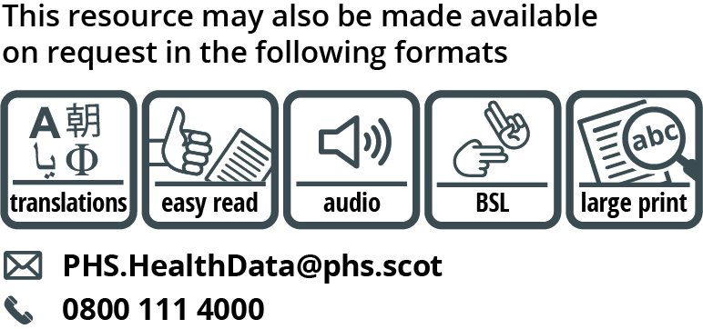

Use the subject line ‘translation request’ if you send an email. Include these details about the person who needs the different format:

* name
* address and postcode
* CHI number
* format or language required

Please tell us if we should always send information in this format. If you’ve asked before for translations of the information we send, it’s on its way to you. Find translations and other formats for past shielding letters at [www.gov.scot/shielding-letters](http://www.gov.scot/shielding-letters)