DIRECTORATE FOR PRIMARY CARE

4th May 2021

Dear Colleague

I am writing to give you an update on the [General Practice Workload and Activity survey](https://forms.office.com/Pages/ResponsePage.aspx?id=veDvEDCgykuAnLXmdF5JmnudJlY2ZJdOoiICWnflWNtUNUdYS0NBMkZSQTJMTEM5SDFaR000UDJOSy4u). I would like to express my sincere thanks to all of the GP practices across Scotland who have so far taken the time to complete the survey. As at 21st April 2021 we have received 1,674 survey submissions from mid-December to date, 257 unique GP practices completed the survey at least once and 14 practices have completed it every week since the beginning of January. A particular thank you to them .

The data has been aggregated to Scotland level by Public Health Scotland (PHS) and overleaf are examples of what the data is showing for this period. This data is management information, and presents Scotland-level estimates based on the returns from practices each week. The data can be used to create national estimates in this way, because analysis completed by PHS shows that the practices who have been responding to the survey are broadly representative of the whole of Scotland (in terms of practice characteristics such as urban/rural location, deprivation, patient demograpics).

We in Scottish Government see this aggregated data weekly, and it has been shared with the Cabinet Secretary for Health and Sport as Chair of the Mobilisation and Recovery Group (MRG). The aggregated Scotland-level data was discussed at the most recent meeting of that group. Supporting General Practice through the recovery and renewal phases is at the forefront of minds at senior levels within Government and the data you are providing, and the subsequent analysis from PHS, is incredibly helpful in informing these discussions and any decisions or proposals made as a result.

As you know, we are working with stakeholders to develop a more sustainable longer term plan for collecting practice activity data, but in the meantime we would greatly appreciate it if practices could continue to collect the data and submit it on a weekly basis, particularly those practices who have been submitting data on a regular basis to ensure that the data continues to be consistent. We plan to announce shortly updated plans for practices to provide this data to us on a regular basis. In the meantime, thank you again for your support and patience.

If you have any queries about the survey then please contact [phs.generalpractice@phs.scot](mailto:phs.generalpractice@phs.scot). Instructions for how to access your practice level data on the Primary Care Information (PCI) Dashboard are available here: <https://www.isdscotland.org/Health-Topics/General-Practice/PCI/Accessing-PCI/>

Yours Sincerely



Heather Campbell

Interim Deputy Director Primary Care

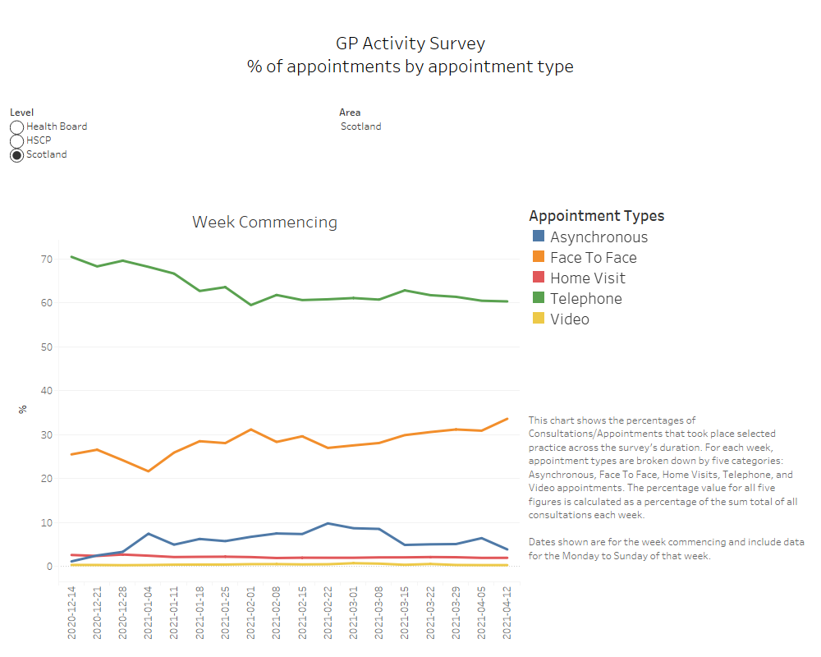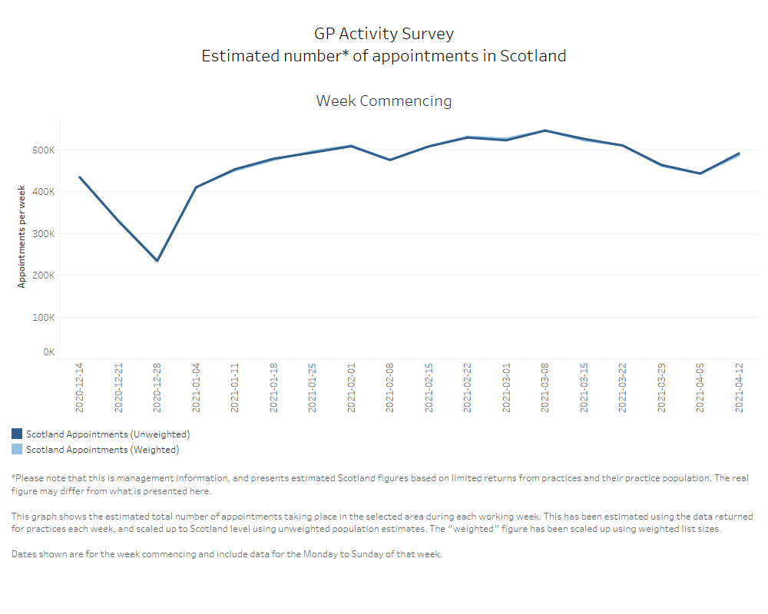

Type of Appointment (%)

