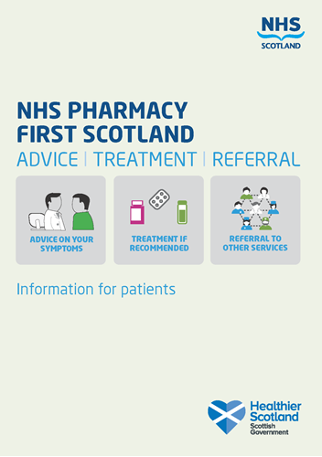

NHS SCOTLAND PHARMACY FIRST SERVICE
INFORMATION FOR GP PRACTICES
Pharmacy First:
Last July (2020) a new service was launched which enables community pharmacies to offer a consultation service for minor illnesses, which could lead to the provision of advice and treatment for patients. The eligibilty for this service was widened from the Minor Ailments Service that it replaced. As a result all patients are now eligible to receive this service, including residents of Care Homes (see Appendix 2).

The Consultation:
Consultations can be conducted by telephone, or using NHS Near Me or most commonly in person at the pharmacy.

What happens next:
After discussion with the pharmacist, one of the following options will happen:
- The patient will be given advice on the management of the minor illness. This may include advice on what over the counter products should be used to manage/treat the condition;
- If absolutely necessary, an NHS supply of medication from the Pharmacy First Approved List may be made by the pharmacy for that individual person;
- The Pharmacist might decided that referral to the GP or another healthcare professional is more appropriate.

Community Pharmacy Development Team
April 2021

Appendix 1
Gastrointestinal
Dyspepsia and Reflux
Irritable Bowel
Acute Diarrhoea
Constipation
Haemorrhoids
Respiratory
Allergy
Cough
Nasal congestion
Nasal allergy
Central Nervous System
Travel sickness
Analgesics and Antipyretics
Migraine and associated symptoms
Musculoskeletal & Joint
Infections
Vaginal Candidiasis
Fungal skin infection
Warts & verruca
Cold sores
Threadworm
Head lice
Scabies
Impetigo
Urinary Tract Disorders (Limited by age)
Eye
Infected eye
Inflammation of eye
Ear : Removal of Wax
Mouth
Oral ulceration and inflammation
Oral Thrush
Skin
Eczema and allergy
Emollients / bath and shower additives
Barrier Creams
Acne
Scalp Disorders
Boils
Simple dressings and tape

Appendix 2
Eligibility for NHS Pharmacy First Scotland (NHS PFS service)
The following persons are eligible for the service:
- a person registered with the Defence Medical services (even if they are
a visitor to Scotland),
- a person registered on a permanent basis with a GP Practice in
Scotland,
- a person registered on a temporary basis with a GP Practice in
Scotland (unless they are a visitor to Scotland),
- a person who lives in Scotland,
- a person who is a gypsy or traveller in Scotland, or
- a person who is an asylum seeker in Scotland or a dependent of an
asylum seeker in Scotland.

The following persons are not eligible:
- a visitor to Scotland

*A more comprehensive list of conditions is provided at Appendix 1

