Today we have launched the Long COVID Campaign, which seeks to highlight the long-term effects of COVID-19 (long COVID) and offers advice on self-managing symptoms. The support available to those who are suffering is also highlighted by signposting further information available via NHS inform

Long COVID Campaign Examples
A snapshot of the campaign creative can be seen below:

Social Image Poster Summary Sheet
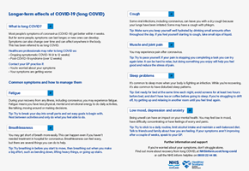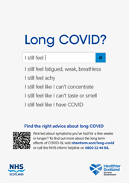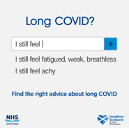

Long COVID Campaign Toolkit
Please find attached the Long COVID Campaign Toolkit, which includes the following:
- Campaign information
- Key messages
- Implementation Support Note for Clinicians
- Campaign Poster
- Static social media assets and suggested social post
- Long COVID Summary Sheet in additional languages and formats

Long COVID Summary Sheet
A summary sheet that outlines key Long COVID information has been created for you to share with relevant audiences, and this has been translated into the follow languages and accessible formats:
- Easy Read, Large Print, Audio, BSL, Arabic, Chinese (Simplified) Polish, Punjabi and Urdu

How You Can Support
- Circulate and display the posters with your audiences
- Post the social image/ copy across your online channels
- Share the summary sheet with individuals/ groups
- Include the editorial in newsletters, email updates, or on webpages
- Share the WhatsApp/ text information with your audiences
- If you don’t already, please follow SG channels across Facebook, Twitter and Instagram and share and retweet content

Campaign Assets
Given the number of assets available, we’ve grouped the assets as per the following:

- The poster is available to download via WeTransfer in A1, A3 and A4 here.
- The social image is available to download via WeTransfer in all sizes here.
- The social copy and WhatsApp copy is available to download via WeTransfer here.
- The summary sheet in English is available to download via WeTransfer here.
- The summary sheet is available to download via WeTransfer in alternative languages and formats here.
- The short and long editorial is available to download via WeTransfer here.

- You can download all of the assets via WeTransfer here.

