27th July 2021
COVID-19 Telephone Hub Overspill Arrangements
Dear Colleagues,
The COVID pathway in NHSGGC has seen a number of changes over the past couple of months and can we express our thanks to you all, and the teams in each GP Practice for enacting these.
There continues to be high demand in the COVID pathway both during the week and at weekends although the numbers have reduced a little.
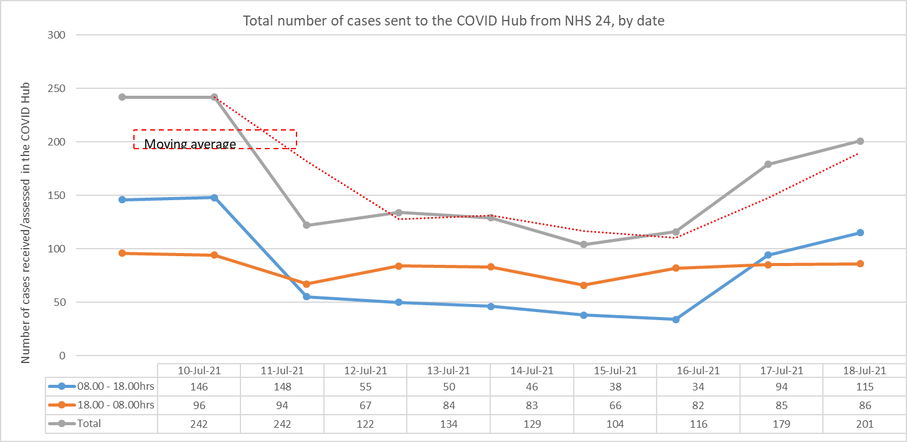
As outlined in our previous communication staffing across the COVID pathway and GP OOH service has been challenging over the past few weeks, and similar to all other services they have both been impacted by sickness, isolation and annual leave.
We remain committed to having a COVID pathway in NHSGGC and are particularly keen to ensure that we are able to maintain the ability for face to face assessments in the CACs to avoid the risk of Covid positive patients attending general practice.
Telephone Hub contingency options
The telephone hub manages calls which have been triaged by NHS24 as requiring a clinical conversation. These calls are passed into the COVID pathway using Adastra. Midweek there had been around 70-80 calls during the day (8am-6pm) although this has dropped to around 30-60 daily last week.

When capacity has been reached in the Telephone Hub we have “direct booked” patients to attend the CAC rather than have a clinical telephone consultation. This has resulted in patients attending F2F when not required, and the vital capacity in the CACs being used in an ineffective manner. The result has been that capacity is often reached early in the day and GPOOH start with a backlog of patients. We recognise that this is no longer the best way to manage this demand and we cannot impact our vital GPOOH service in this manner.
We have been working closely with Clinical Directors, GP Subcommittee and management of the pathway to consider suitable alternatives. We have agreed that when capacity in the telephone hub is reached there will be an ask of GP Practices to carry out the telephone Clinical Consultation. We anticipate at current levels there will be a maximum of one call daily per Practice.
The ability to refer into the CAC for F2F assessment remains in place as agreed as a key part of the COVID pathway
How Will This Work?
- NHS24 will continue to transfer calls into the COVID pathway as usual- this will allow ongoing collation of data and demand. These calls relate to patients phoning in relation to COVID-19 and have been assessed by NHS24 as requiring a clinical telephone assessment.
- If capacity is reached in the Telephone Hub or a patient has waited more than 40 minutes for a call back, the patient contact record will be transmitted to the patient’s GP Practice.
- The Adastra patient contact record will be sent to the GP Practice, the method for sending messages will replicate the existing process for all OOH and COVID contacts, usually EDT/Docman.
- A member of the administration team from the COVID pathway will phone the GP practice to alert them of the message and the need for action by the Practice .
- There is no expectation that a F2F consultation is to be carried out by the Practice - this is telephone assessment only, and the option of referral to CACs (and SATA) remains in place. Please consider previous correspondence in particular relating to children who we would encourage to be seen in Practices where possible.
- No calls will be transferred to GP Practices after 5pm.
- It will be up to Practices how they choose to deal with these calls when received by their teams.
- Records will be kept in relation to when the overspill arrangements are used, accurate reasons for this and the numbers of calls transferred to Practices.
We will continue to work to staff the Telephone Hub to match capacity and demand. We understand that workload in Practices is high and we are facing significant demand and challenges. However we believe that this is the safest option for patients and will allow us to protect the F2F offering of the pathway.
Whilst we believe this will support the pathway midweek there remains a requirement for GPs to pick up shifts in the evenings and at weekends to manage the COVID workload and also to ensure that our GPOOH service is supported and protected. All shifts are advertised on Rotamaster or by contacting Anne in the OOH service 0141 616 6211. A small amount of time worked by larger number of GPs will make a huge difference to our colleagues.
Again can we thank you for your support with the changes to the pathway.
Kind regards
Dr Kerri Neylon
Deputy Medical Director for Primary Care & Deputy Responsible Officer
Email Kerri.Neylon@ggc.scot.nhs.uk
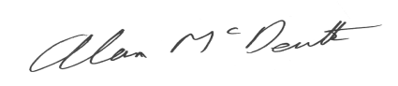

Dr Alan McDevitt
Chair, Greater Glasgow and Clyde GP Subcommittee

