NHS GG&C GP Survey - w/c 06-Dec-21

Practice Participation
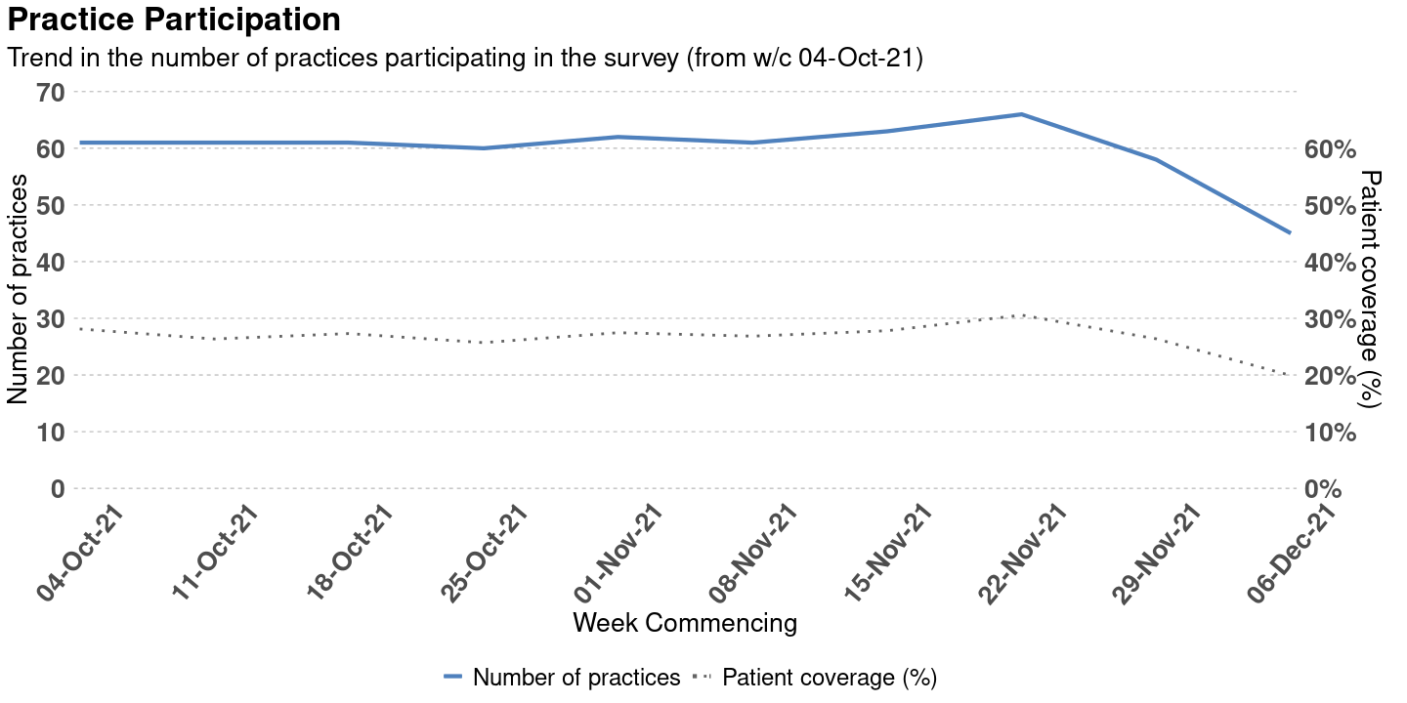

Page Break

HSCP Participation
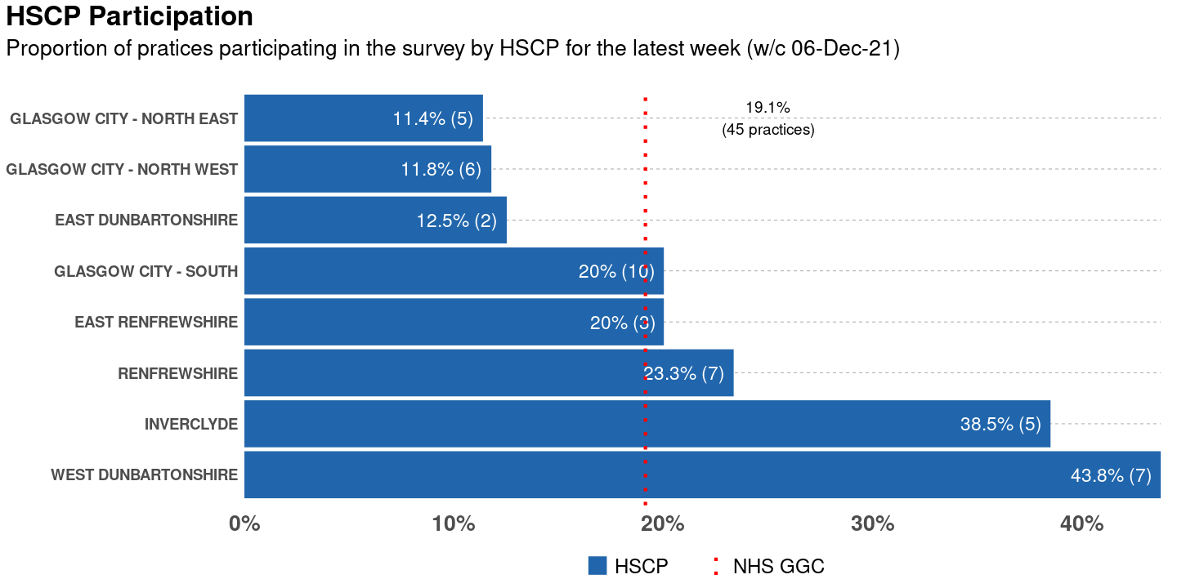

Page Break

Estimated Number of Appointments - NHS GGC
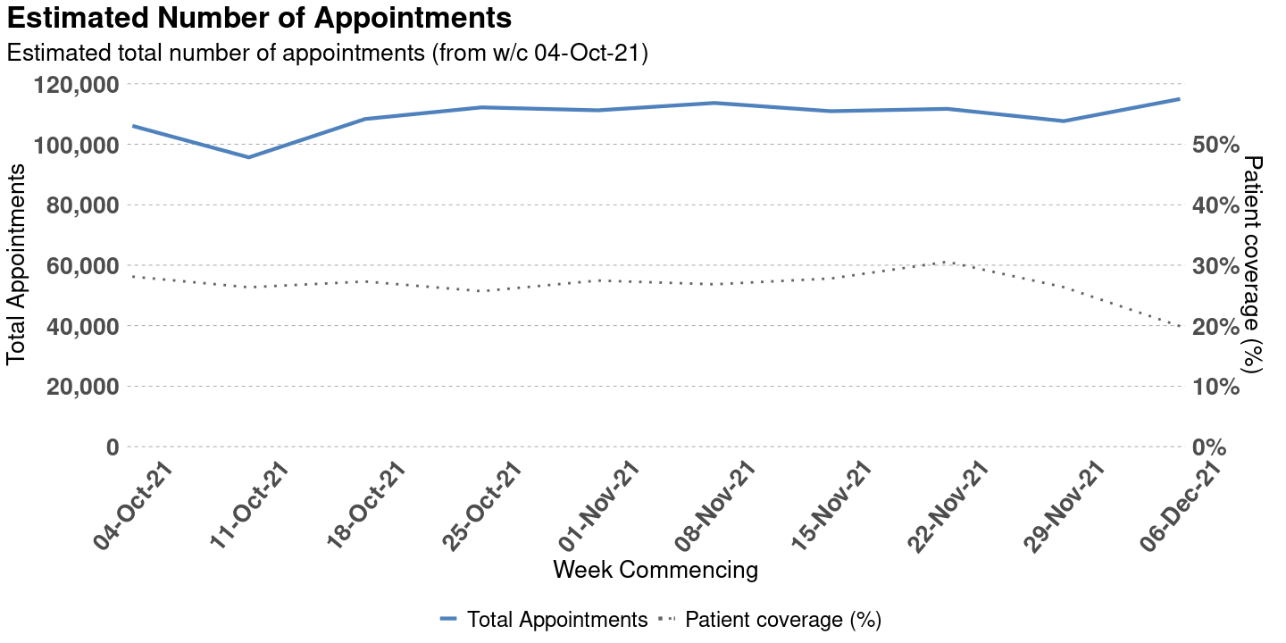

Page Break

GP Sessions - NHS GGC
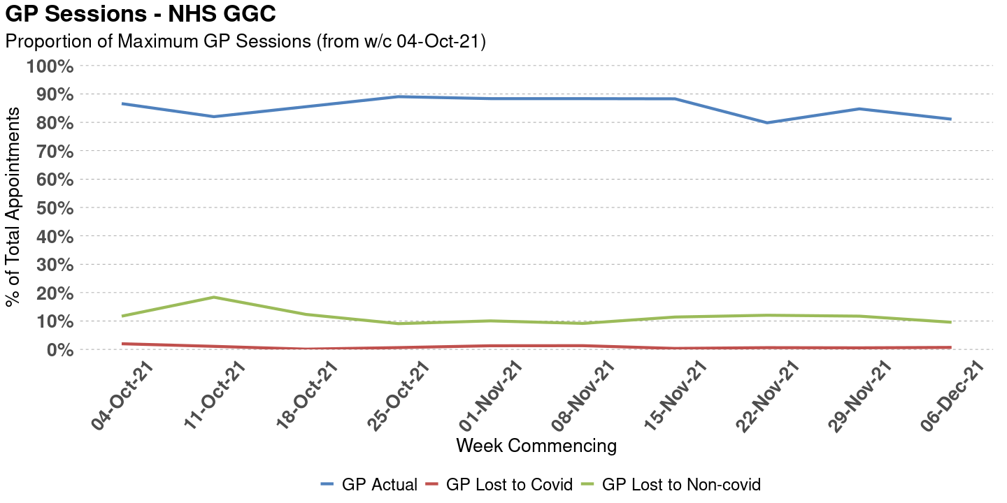

Page Break

Non-GP Sessions - NHS GGC
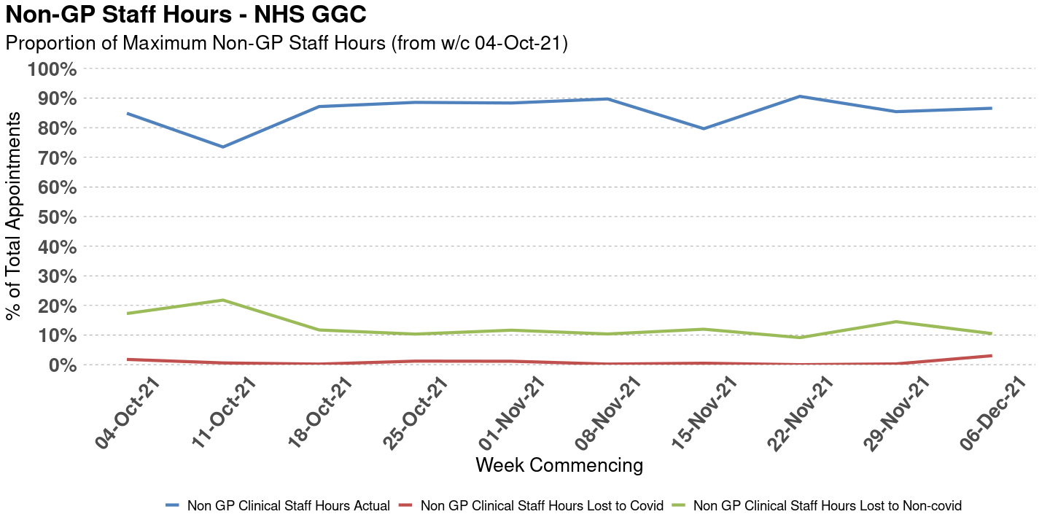

Page Break

Appointment Type - NHS GGC
