|  |  |
| --- | --- |
|  | 14 December 2021 |

|  |  |
| --- | --- |
| Directorate for Chief Medical Officer  Professor Gregor Smith  Chief Medical Officer  St Andrews House | Regent Road | Edinburgh | EH1 3DG |  |

**IMPORTANT: PERSONAL**

**Your Community Health Index (CHI) number: <<CHI>>**

**Updates for young people on the Highest Risk List**

Dear [forename] [surname],

With winter now underway, I wanted to write to you about a few important points. Firstly, I wanted to update you on the new Omicron variant of the virus. I’ll also share some advice about vaccinations, lateral flow testing, help with mental health and wellbeing, socialising, and going to school or college. All of these issues will be key as we work together for a safe and happy festive season.

**Omicron variant**

We do not know all that we need to know about the new variant yet. Early signs suggest it can pass from person to person more easily. Further work is underway to find out more about the effects on vaccine protection and severity of disease.

However, what we do know with certainty is that following the protective measures with extra focus and effort now will help to reduce its spread. These include washing your hands regularly, wearing face coverings when you need to, having vaccinations, testing regularly, and following advice around things like ventilation (such as keeping windows open if you can). We know these measures are effective and we continue to encourage everyone to follow them to protect us all.

If you are on any medication which suppresses your immune system, I am advising you to take extra care and to follow the advice of your GP or clinician. When your immune system is suppressed, even for a short period of time, it’s important to be particularly careful to follow all the protective measures, as you may be more susceptible to viruses such as Covid-19.

**Advice on socialising**

The First Minister has given some new advice about socialising. This advice is the same for everyone in Scotland. Cut down unnecessary contacts as much as possible. In the run up to and after Christmas, please avoid socialising with people in other households as much as you can. If you are socialising indoors at home or in public places, limit the number of households in your group to a maximum of 3. And test before you go.

We are not asking you to cancel or change your Christmas plans, and we are not proposing limits on the size of Christmas gatherings. But we will issue guidance to help you make Christmas safer. Reducing your contacts before and after Christmas is important and will help do this.

**Vaccinations if you’re severely immunosuppressed**

If you’re aged 12 or over, you were severely immunosuppressed at the time when you had your first or second dose, and you have not had your third dose yet, your Health Board will now invite you for your third primary dose. Some immunosuppressive treatments may affect when you get your third dose. Your GP or clinician can give you advice about this and when to book your appointment.

A third primary dose of a Covid-19 vaccine is an extra ‘top-up’ dose to help increase the level of protection for people who may not have generated a full immune response to the first two doses and might be less protected than the wider population.

A third primary dose is different from a booster dose. A booster dose is an additional dose to extend the duration of protection from previous doses.

Find out more about third vaccine doses at [www.nhsinform.scot/covid19vaccinethirddose](http://www.nhsinform.scot/covid19vaccinethirddose)

This includes more information about who can get a third dose and when.

**Vaccinations for all children and young people aged 12 to 17**

All 12 to 17 year olds are now eligible for a second dose of Covid-19 vaccine. 12 to 17 year olds who are on the Highest Risk List, or who are a household member of someone who is immunosuppressed, can receive their second dose if it’s been at least 8 weeks since their first dose. All other 12 to 17 years olds can receive their second dose if it’s been at least 12 weeks since their first dose.

People aged 12 and over who have not received a letter inviting them for a vaccination can arrange an appointment by calling the National Vaccination Helpline on 0800 030 8013 (8am – 8pm daily) or by visiting a drop-in clinic. People aged 16 and over can also book via the online portal at [register.vacs.nhs.scot](https://register.vacs.nhs.scot)

You can go along to a drop-in clinic at a time that suits you. You can find your nearest drop-in clinic on the NHS inform website at [www.nhsinform.scot/vaccinedropinclinics](http://www.nhsinform.scot/vaccinedropinclinics)

**Support with transport to your vaccination appointment**

Help with transport to your vaccination appointment is still in place if you don’t have your own transport or support from family, friends or other networks, or use of public transport to get to your appointment. You can contact the National Vaccination Helpline on 0800 030 8013 (8am – 8pm daily) who will put you in touch with local support.

**Easier lateral flow tests now available**

New lateral flow tests that only need a nose swab, not a throat swab too, are now available. These tests are free and now much easier to use. The tests are effective at detecting the new Omicron variant. If you’re at secondary school, please ask your school for some tests, free of charge. You can also order them from [www.gov.uk/order-coronavirus-rapid-lateral-flow-tests](http://www.gov.uk/order-coronavirus-rapid-lateral-flow-tests) or collect from a test site or local pharmacy. From early December many local authorities will also be making free lateral flow tests more widely available in places like supermarkets, transport hubs, local markets, local council offices and libraries.

If you’re at secondary school, please continue to make use of the regular, twice-weekly testing that they offer. It’s also important that you report all test results, whether positive, negative or void.

We are now also asking everyone of secondary school age or older to do lateral flow tests before they meet people from other households outwith school or education. This could include friends who are not at school with you, family who don’t live with you or carers. This will help to protect you.

**Support with mental health, wellbeing and loneliness**

I know that the pandemic has affected mental health and wellbeing, and that winter can be a difficult time for many people. At the moment you may be feeling anxious, worried, down or lonely. Because of this I want to remind you that lots of help is available to support you and your mental health and wellbeing.

There are many ways to get help and support, including speaking to your GP, General Practice nurse or other health workers in your GP practice. You can also talk to someone in your clinical team, such as your specialist nurse, or a trusted adult at your school like a teacher or a school counselor.

I’ve included contacts who can help in the information with this letter. These include numbers you can call if you need someone to talk to right now.

**Safety measures in schools kept under review**

The Covid-19 safety measures in schools have remained stable over the course of this academic year. Given more recent developments, we will consider if that position remains appropriate and whether there is any more we can do to further reduce risks. My advice is still that children and young people can attend education settings unless their clinician has advised otherwise.

Yours sincerely,

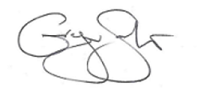

**PROFESSOR GREGOR SMITH**

CHIEF MEDICAL OFFICER

**More information**

**Support with mental health and wellbeing**

**GPs and people in your clinical team**

If you’re struggling, remember you can always talk to your GP or someone in your clinical team – like your physiotherapist or specialist nurse, if you have one.

**NHS 24**

Call 111 for urgent support if you are in mental distress. Open 24 hours a day.

**Aye Feel**

Aye Feel from Young Scot has information about how to look after your mental health and wellbeing and has links to lots of other information on a wide range of topics. You can find this information at: [www.young.scot/campaigns/national/aye-feel](http://www.young.scot/campaigns/national/aye-feel)

**Parent Club**

Parent club provides information for your parents and carers about how they can help and support you. Parents and carers can access information at: [www.parentclub.scot/topics/coronavirus](http://www.parentclub.scot/topics/coronavirus)

**Childline**

Childline offers support if you need to talk to someone about how you feel. On their site they have message boards so you can share how you feel with others, alongside having a lot of help and resources on wellbeing. Visit [www.childline.org.uk](http://www.childline.org.uk) or call 0800 1111 (lines open 24 hours. Calls are free).

**Help available in schools**

Within schools, you can talk to a member of staff who you trust who can help you get extra support if you need it. You can also access counselling support through secondary schools. Counselling can help you explore how you are feeling, any issues you may be having and provide you with any support you may need.

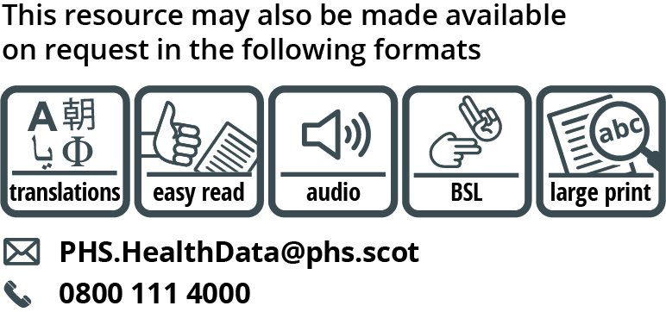

Use the subject line ‘translation request’ if you send an email. Include these details about the person who needs the different format:

* name
* address and postcode
* CHI number
* format or language required

Please tell us if we should always send information in this format. If you’ve asked before for a translation of the information we send, it’s on its way to you.

Find translations and alternative formats for past letters to the highest risk group at [www.gov.scot/highest-risk-letters](http://www.gov.scot/highest-risk-letters)

**Data Protection Statement**

You have been identified from either your GP practice, local Health Board or securely stored national data in order that we could write to you. We want to reassure you that this information has only been shared in a limited way within the NHS in Scotland and did not include your medical record. During this time, we will keep your contact details in case we need to contact you again. We will also notify your GP and your Health Board that you have been contacted in order that they can provide appropriate support. To provide some of the support noted above, we may share your contact details only with your council. This is only so that they can support you during this difficult time. This action is only being taken due to the current Covid-19 outbreak. We want to assure you that your local council would not receive any details of your medical condition or health record.

You can request your contact details to be removed from the highest risk list by asking your GP or hospital clinician.