COVID-19 Pathway Update Wednesday 26th May 2021

Dear Colleagues,
I am writing with an update on the Covid19 Community Pathway.
Background
The COVID-19 community pathway was set up in March 2020 with two main aims:
- Assessment of potentially COVID positive patients and providing a dedicated site, COVID assessment centre (CAC), for face to face review primarily to determine whether hospital assessments required
- To protect General Practices to ensure ongoing access for patients with “non-COVID” health issues.
The pathway has a number of components:
- Telephone Hub staffed by GPs, receiving calls from NHS24 and carrying out clinical consultations. These sessions are advertised via the GP Out of Hours service, on the Rotamaster site, and are across a 24/7 period
- COVID assessment centres- currently 4 across GGC (Barr Street, Linwood, Clydebank & Renton). These are staffed by GPs and ANPS and supported by Nursing and AHP teams who have been deployed from other services. Sessions for Barr Street are advertised on the GPOOH Rotamaster site. These provide Face to Face assessment with a view to whether admission is required or to provide further advice for management at home. The CAC was primarily established to assess and manage likely Covid rather than a wider range of conditions.
- GP Out of Hours- when the CACs reach capacity and close, and during the out of hours periods the GPOOH service assesses these patients in the PCECs, as part of their usual work.
- Currently Barr Street is open 10-10 Mon –Fri and 10-6 at weekends. Linwood, Clydebank and Renton are open usual working hours Mon- Fri.
There is direct GP access to the pathway where following clinical consultation it is felt that the patient requires urgent F2F assessment in the COVID pathway, with referral through SCI-gateway. Around 2/3 of CAC attendances are currently referred by General Practice. Depending on capacity it is likely that patients will be appointed to CACs outside their HSCP area and travel time needs to be built in to support access.
Alternative pathways are in place for direct referral to SATA where assessment for possible admission is clearly required.

Current Situation
There remains a clear commitment to maintaining the COVID pathway for the foreseeable future. It remains a priority to ensure that COVID patients are seen in the pathway and not in General Practice in order to meet the original aims of the pathway of streaming and cohorting Covid cases away from mainstream General Practice.
However we need to ensure that we are seeing the right patients through this pathway and that support is provided to the pathway.
Demand has markedly increased across the pathway over the past 3 weeks.
- The Telephone Hub calls transferred from NHS24 have increased by 67%
- The GP Advisors in the Hub convert around only 30- 35% of calls to F2F assessment
- The week of 17-23 May has seen a 64% increase in COVID pathway attendances since the comparable week in April
- Referrals from the pathway to SATA (Acute) remain between 2-4%
- Many of the patients referred into the pathway from all routes have not had COVID testing and this is being carried out at the CACs during attendance.
- There are high numbers of young children being seen in the pathway- 42% of attendances in the week of 17-23 May were aged under 4, with a further 15% under 16. These patients are often very distressed during their attendance and require longer appointment times which reduces the overall capacity in the CACs.
- A deep dive of a week of CAC attendances in April 2021 evidenced <1% COVID positivity in children with the only positive result coming from a family known to be COVID positive. Nationally the COVID incidence in the 0-4yr group is <1%. The highest positivity rates are in the 16-40yr group
- The deep dive exercise evidenced many patients being referred to the pathway without COVID symptoms
- Acute services are now seeing patients in areas other than SATA when the perception is that the attendance is “non-COVID”

We recognise that demand has increased significantly across general practice over this same period, and that the Covid pathway remains a vital approach to ensure appropriate capacity and response across primary care.

Current Challenges
The current escalation in demand is causing sustainability challenges for the whole pathway.
Additional clinical sessions have been advertised for the Telephone Hub but have yet to be filled.
The CAC teams have been contacting GPs to encourage engagement in the service but with little update as yet and many shifts are unfilled, which further reduces appointments and capacity in CACs.
During the week when referrals are sent from Practices, appointments are allocated to patients in the CACs. On some days patients referred at 2-3pm are not appointed until far later in the evening. Once capacity has been reached in the CACs which can happen around 3pm, patients can no longer be appointed and therefore have to wait until the GP OOH service opens to be allocated appointments. This has a huge impact on colleagues working in the GPOOH service who are dealing with this work, but also poses a risk for patients who sit at the interface of services.
Discussions have been occurring between HSCP teams to see if increased numbers of Nursing and AHP support staff can be deployed to the CACs. This is increasingly difficult as other services are remobilising and additionally then reduces access to other services for patients (and GPs).
In the longer term many of the staff working in the CACs will have to return to their original roles and the accommodation returned to its usual purpose. This is particularly pressing in some areas in order for HSCPs to continue to deliver on their PCIPs, particularly in respect to ANPs and CTAC services.
We previously wrote to you in 2020 about the ‘practice emergency contribution’ model which would ask practices to provide staffing input to the CACs in proportion to list size as part of escalation measures if attendances rose significantly. This was not required over the winter and we remain keen to avoid this if at all possible given the current pressure on practices.
Immediate Asks
Firstly can I ask that patients are referred in line with purpose of CAC, not for testing BUT where urgent F2F assessment is required, cannot be managed by telephone or video consultation and the presentation is suitable for a service focused on COVID.
To ensure sustainability of the pathway I am asking for you to consider supporting this by picking up shifts either in the Telephone Hub or the CACs. Even a few hours will help to increase capacity to support patient care and you can work across other areas.
However, there is recognition of huge demand and increasing workload in the system, especially in General Practice, which shows little signs of reducing at present. I appreciate that this is a difficult ask, particularly at this current time.
The contacts for these areas are as follows:
Telephone Hub- Derek Johnstone 0141 616 6215 and via Rotamaster, GPOOH booking system
Barr Street CAC- Derek Johnstone 0141 616 6215 and via Rotamaster, GPOOH booking system
Linwood CAC- RenfrewshireCHTesting@ggc.scot.nhs.uk or George.Wilkie@ggc.scot.nhs.uk or telephone 01505 821418
Clydebank & Renton CACs- Anna Crawford 07811 247708, Anna.Crawford@ggc.scot.nhs.uk
Kind regards
Dr Kerri Neylon
Deputy Medical Director for Primary Care, NHS Greater Glasgow & Clyde

RECENT DATA
Pathway attendances week 17-23 May
Age Group | CAC’s | PCEC | Total
0-4 years | 248 | 130 | 378 (42%)
5-11 years | 86 | 27 | 113 (13%)
12-15 years | 13 | 8 | 21 (2%)
16 + | 281 | 111 | 392 (43%)
Total | 628 | 276 | 904

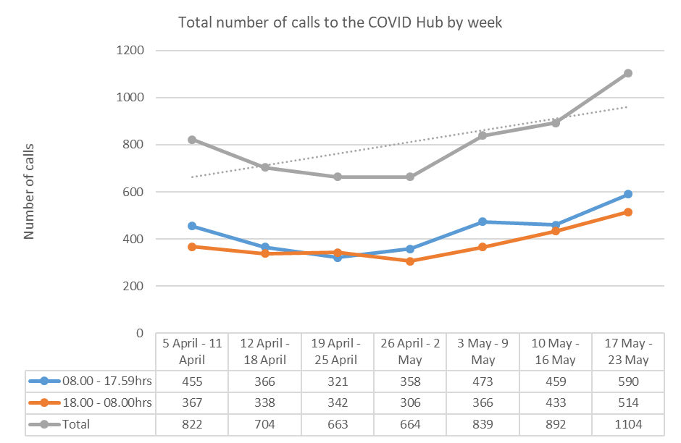

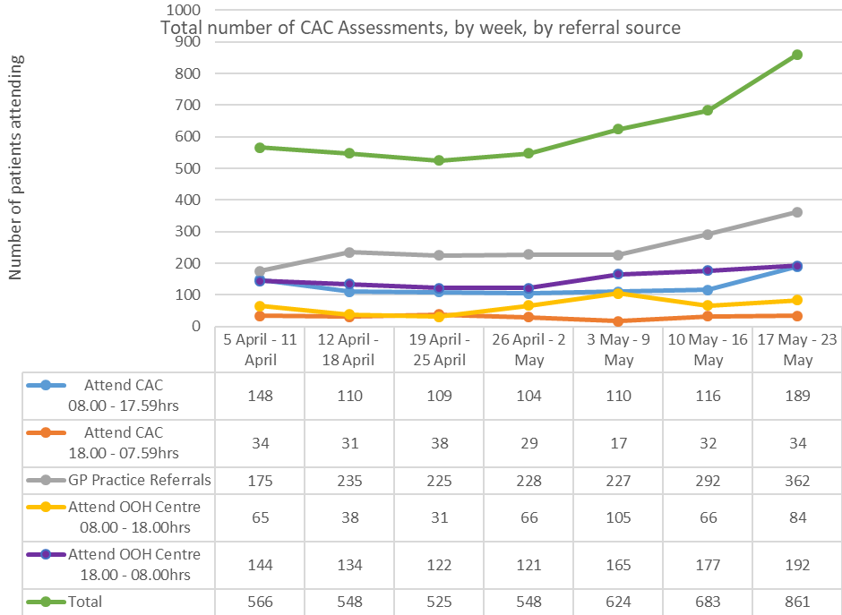

Deep Dive of CAC attendances 11-17th April 2021
Age Group | No. of patients | Referral from GP | Referral via Hub | Discharge home | Hospital referral | Test Positivity
0-4yr | 126 (30%) | 79 (63%) | 47 (37%) | 114 (90.5%) | 12(9.5%) | 1 (1%)
5-11yr | 24 (6%) | 11 (46%) | 13 (54%) | 24 (100%) | 0 | 0
12-15yr | 7 (2%) | 5 (71%) | 2 (29%) | 6 (86%) | 1 (14%) | 0
16-29yr | 60 (14%) | 28 (47%) | 32 (53%) | 55 (92%) | 5 (8%) | 6 (11%)
30-49yr | 80 (19%) | 38 (47.5%) | 42 (52.5%) | 58(72.5%) | 22 (27.5%) | 16 (25%)
40-69yr | 97 (23%) | 64 (66%) | 33 (34%) | 69 (71%) | 28 (29%) | 8 (10%)
70yr | 23 (6%) | 12 (52%) | 11 (48%) | 16 (70%) | 7 (30%) | 1 (6%)

