Annex B
Directorate for Population Health
Shielding Division

Date: XX July 2021

IMPORTANT: PERSONAL

Dear Patient,

Your CHI number: <<CHI>>

I am writing to you because you are included in the highest risk group in Scotland (previously known as the shielding list). This is because of your risk of severe illness from Covid.
Our records show the address we hold on the shielding list, as shown above, is different from the address held by the GP you are registered with, [insert address].

What you need to do now
To ensure you continue to receive letters for the highest risk group, as well as any future appointments, please ensure your most up-to-date address is held by your GP practice, as this will be the address used for future communications. If you have moved out with the boundary of your previous GP practice, you may need to register with a GP practice in your local area.
Your data
If you have any questions about the use of your data, please contact Public Health Scotland. Information on how to do so is available at publichealthscotland.scot/our-privacy-notice

Online help and support
You can find out more about the latest Scottish Government advice for people at highest risk by going to www,mygov.scot/shielding
If you have any concerns about your health, please discuss them with your GP or hospital clinician.
If you have any questions about updating your address, you can contact us by email at phs.healthdata@phs.scot
Please use the subject line ‘Change of address request’. You should also include your full name, current address and CHI number (shown above). Public Health Scotland can then update your details.
If you are unable to reply by email, you can call the National Assistance Helpline on 0800 111 4000.

Yours sincerely,
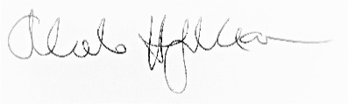
Orlando Heijmer-Mason
Head of Shielding Division

