# EMIS - EScro Vaccination Tool Install and User Guide

Change Log

|  |  |  |  |
| --- | --- | --- | --- |
| V1.0 | 20.01.21 | Initial release |  |
| V1.1 | 29.01.2021 | Revisions from pilot feed back and specific for Emis |  |

The EScro vaccination tool provides a facility for practices to import external vaccinations provided by third party providers or vaccinations provided in-house but recorded using the National Vaccination Tool (Turas), directly into Vision or EMIS. At present the process to file vaccination data into the patient record is not fully automated, so that practices are able to review records before saving the data into the individuals record within Vision or EMIS. The flow of the data from the central National Clinical Data Store (NCDS) is outlined below: -

GP clinical system

National Clinical Data Store

Local Escro Database

Vaccination Import tool

The application can be installed from the following link. It is suggested this should be installed on the admin users’ machines who will be responsible for running the tool each day, it would not normally be needed to be installed in a high number of machines.

[https:/www.escro.co.uk/vacctool/vacctool.htm](https://www.escro.co.uk/vacctool/vacctool.htm)

**Note: Please use Internet Explorer or Microsoft Edge, the install may have issues in Chrome or Firefox if the correct plug in is not installed**.

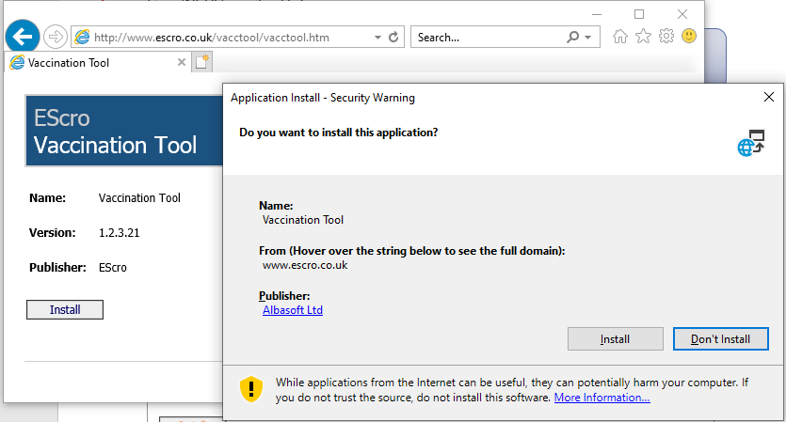

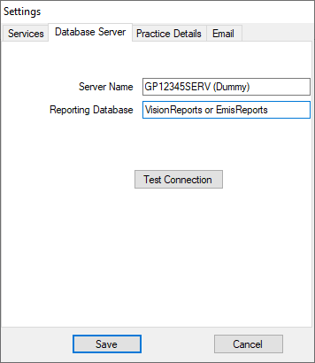Please agree to any prompts asking if you wish to open or run the package

If you already use another Escro application on your PC, such as STU, the Shielding Tool or the At Risk Flu tool, your PC will already be configured and you will not be presented with the Settings screen (as per screenshot) and you can move to the “Running the Vaccinations Import” section of this guide.

However, if this is the first time an Escro package has been installed on your PC, you will be required to enable the settings as per the screenshot and will be prompted to enter your server and database settings.

Please contact the Escro helpdesk or use the following link to obtain these.

[STU Server Settings (escro.co.uk)](http://www.escro.co.uk/es_news/serversettings.aspx)  
**(use 255921 as the pin number)**

Server name is the local server where your EScro database is held, database will be VisionReports or EmisReports depending on your clinical system. The Test connection button will check connectivity before you save the settings.  
Following installation an Escro vaccination tool icon will be created on your desktop.



## Running the Vaccinations import

The data to populate the vaccinations report will be created in the EScro database when the scheduled task for the EScro data pump runs overnight.

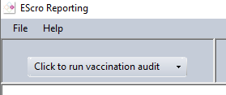

The audit routine can be launched by clicking on the run button at the top left of the screen. Depending on the practice size this may take a minute or two to run the audit.

In the unlikely event that the audit routine detects that the Escro Data pump has failed to run overnight on your system, you will see the following warning displayed. Please contact the Escro Helpdesk (details at the end of the document) who will run the data pump manually and investigate the failure issue.

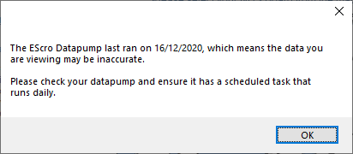

There will now be additional tabs at the top of the screen. The “Covid Vaccinations” tab with dashboard is still in development but will provide an activity summary for target vaccine groups once the final specifications for the individual at risk cohorts are defined.

The main tab for importing vaccines is the “**Export Backfill**” Tab

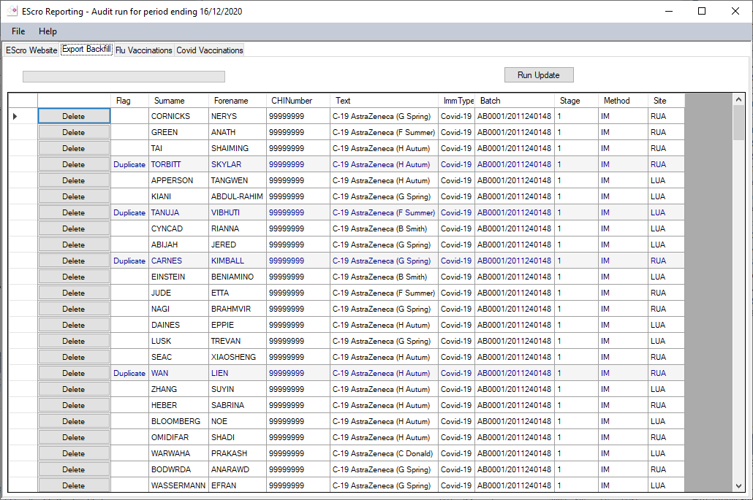

## Export Backfill

This screen will display a list of the current records available for importing into EMIS and Vision. Validation checks will be performed against the patient’s current record and any duplicate records will be flagged on the report. A record can then be checked by opening in Vision or EMIS clinical system. If it is decided not to import an individual patient’s vaccination record, it can be removed from the import list by clicking on the delete button.

We would recommend that where duplicates are a result of manual data entry at the practice that you accept the imported result and delete the manual entry in EMIS or Vision. The imported data is generally more complete and structured.

Once you have verified that the records are satisfactory and you have removed or accepted any duplicates, click on the “Run Update” button to begin the import.

The system will now automatically run through each record highlighting each row as it is successfully imported. Any records where the system is unable to file the record will be highlighted in red and marked as “UPDATE FAIL”. Any records failing to import will be automatically reported to Albasoft overnight to be investigated further.

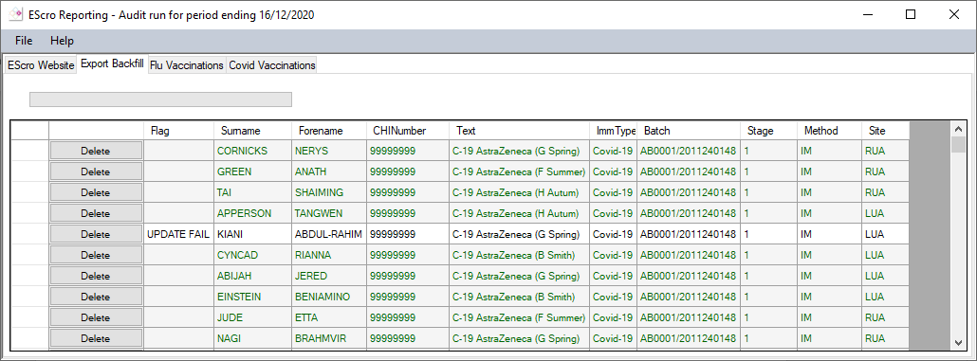

Duplicate records  
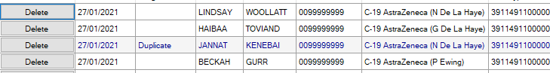

The system will check for any existing Covid immunisations recorded on the same or previous 20 days (Stage 1 or 2). If these are found they will be marked at “Duplicate” on screen and highlight in blue. These should be checked in the clinical system before proceeding with the import. You may choose to delete the incoming record from the list by clicking on the delete button on the left, or you may choose to delete the existing record in Vision or EMIS

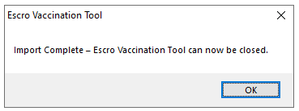Once all records have been filed you will receive the notification below and the program can be closed.

On completion of the import the entry can immediately be viewed in **Full history** within EMIS.

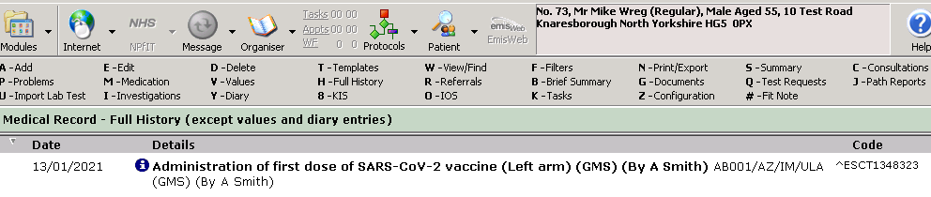

## Help Desk and Contact details

Main Number 01463 572000 (option 1)

Email helpdesk@albasoft.co.uk

## Technical Notes for Health Board IT Teams

**Click once applications**

The import tool is deployed as a Microsoft “[click once application](https://docs.microsoft.com/en-us/visualstudio/deployment/clickonce-security-and-deployment?view=vs-2019)” that uses specific security settings to allow users without admin permissions to install and run. The program will not be installed to C:\Program Files but is held in the users local programme cache and runs in a restricted protected mode area on the PC. The install is specific to each login and cannot be shared between users on the same PC. Each user will require to install the program. The is a specific security feature of click once applications.