

Logging in to Pecos

[*https://nhsscot.pecosipm.com*](https://nhsscot.pecosipm.com)

Enter your user id and password and click login

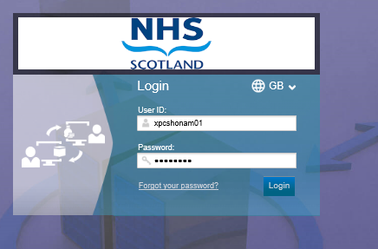

To find PPE items available to order, go to Quick Search and type ndc and search

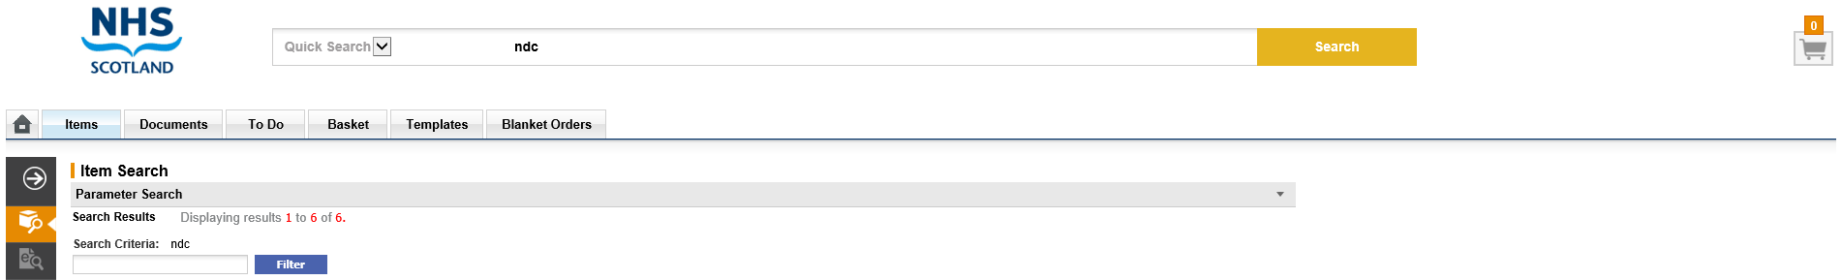

You can see that there are 6 items to choose in the catalogue.



The full catalogue is displayed below

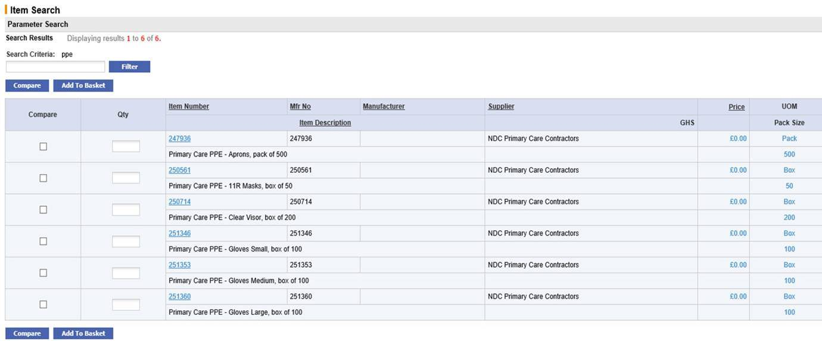

Enter the quantities that you require in the box to the left and click on add to basket

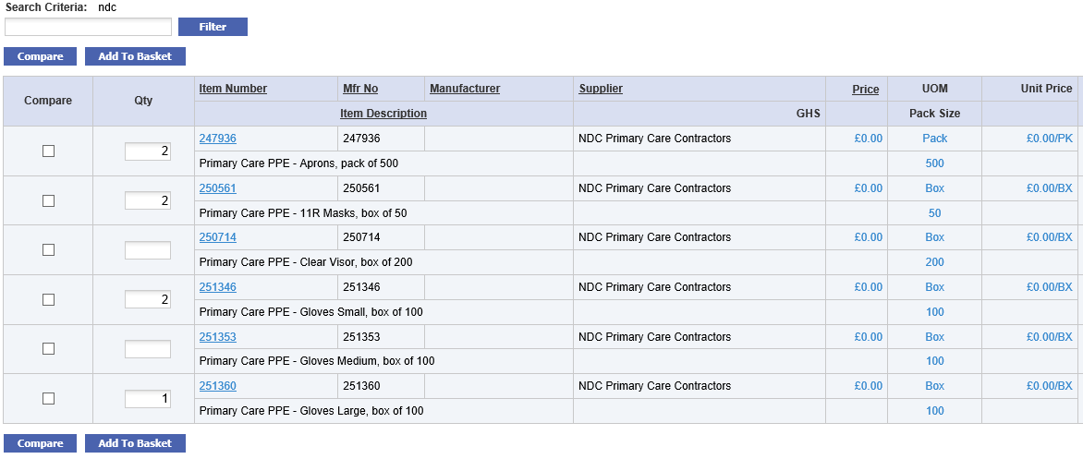

Click on basket or the icon in top right







If you have selected everything you require, you can now click submit and your order will be transferred to NDC for processing and shipment

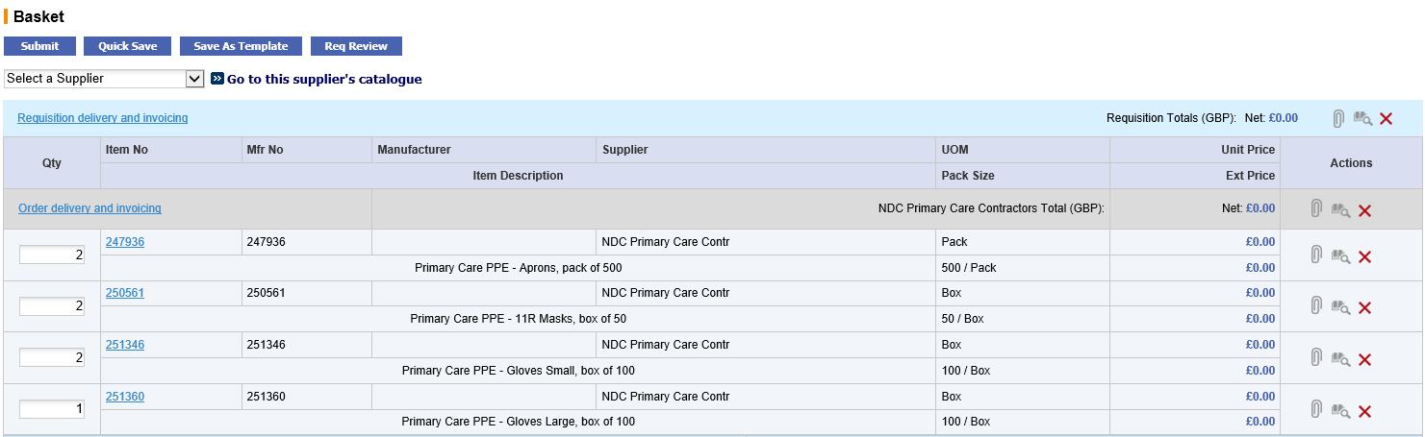

Once your order has been submitted successfully you will receive an email confirmation.

If you experience any issues raising an order or have issues accessing the system, please raise a call through the NSS ServiceNow portal.

<https://nhsnss.service-now.com/nssexternal>