Directorate for Chief Medical Officer  Dr Gregor Smith  Interim Chief Medical Officer  St Andrews House | Regent Road | Edinburgh | EH1 3DG | 

[Patient Name
Patient address Line 1
Patient address Line 2
Patient address Line 3]
January 2021

IMPORTANT: PERSONAL

Your Community Health Index (CHI) number: [CHI NUMBER]

ADDITIONAL PROTECTIVE MEASURES

Dear [Patient],

The First Minister announced on Monday 4 January that there will be new additional protective measures from Tuesday 5 January for the whole of January for all parts of Scotland that were at level 4. These new restrictions and guidance are needed to curb and reverse the recent strong growth in transmission of the new coronavirus variant.

I wrote to you on 21 December to provide advice on living or working in level 4 areas. This included a table of extra advice. I am writing to confirm that my extra advice for you has not changed except in relation to going to work where it is not possible to work from home. My advice is that while the area where you live or work is under these additional protective measures, if you cannot work from home, you should not go to work. This letter provides more information about this below.

The first additional measure which the First Mninster has set out for everyone is that our fundamental advice is to stay at home whenever possible. Staying in your household is the single best way of staying safe. This requirement to stay at home will be set out in law. You will only be allowed to leave your house for specific reasonable purposes. These will include education, caring responsibilities, essential shopping and exercise. Visiting someone you are in an extended household with, will count as a reasonable purpose.

The rules on outdoor meetings are also being changed. From now on, a maximum of two people will be able to meet from up from two households. There is more advice at Coronavirus in Scotland - gov.scot (www.gov.scot)

As before, we are asking you, as someone on the shielding list who is at the highest risk from coronavirus, to follow the same restrictions and advice as everyone else.

This includes that anyone who is able to work from home, must do so.

However, I have now added additional advice for you which is specific to going to work. Due to what we now know about the higher transmissibility of the new variant, I am now writing to advise you that if you cannot work from home, you should not attend work for as long as these additional protective measures are in place in the area where you live or work.

This additional advice on going to work does not apply to areas that remain at level 3. If you live or work in a level 3 area, you can continue to go to work if the workplace can be made safe.

While level 4 restrictions across mainland Scotland increased protection for those who are at most clinical risk, we have considered what additional measures we can advise to reduce the increased risk of transmission of the new strain of coronavirus and further reduce opportunities for infection. One of the key areas we can focus on is the workplace.

Apart from this, the extra advice in the table attached to your previous letter has not changed and is attached again for your information. It is also available online at www.mygov.scot/shielding. Please consider all of the advice in the table and think about what is right for you.

My advice on going to shops or chemists for essential purposes has not changed. You can continue to do this if you choose to do so, while following the advice and guidance we have highlighted in the Balancing the risk of daily activities during coronavirus booklet sent to you in early December, or on-line at Coronavirus (COVID-19): guidance on support, information, food and other essentials - gov.scot (www.gov.scot). I am continuing to advise that you should not use public transport (including taxis) while these additional protection measures are in place.

There are a wide range of ways you can now shop and get your shopping delivered. And you can still sign up for priority on-line supermarket delivery slots if you have not done so already at Coronavirus - support if you've been shielding - mygov.scot.

As before, it is important to use family, friends, and neighbours for support. But if you need any additional advice, information, support or help, you can call the free National Assistance Helpline on 0800 111 4000 (Monday to Friday, 9am to 5pm). This will put you through to your local authority which can assess your needs and arrange additional support.

What to do if you can’t go to work

If your employer cannot make it possible for you to work from home, you will be able to use this letter as evidence for your employer to show that you should not go into work, including for statutory sick pay purposes. All you need to do is show them this letter, which serves a similiar purpose to a fit note, and is called your Shielding Notification. You do not need a separate fit note from your GP.

If you are not attending your workplace due the advice in this letter, your employer, at their discretion, may be able to furlough you through the Coronavirus Job Retention Scheme which has now been extended until April 2021. If you are furloughed, HMRC will give a grant to your employer to cover 80% of your normal salary, and your employer will need to pay National Insurance and pension contributions. I would encourage you to discuss this directly with your employer.

Otherwise you may be eligible for Statutory Sick Pay, Universal Credit, or other benefits, during this period. To find out further information about what benefits you may be entitled to, speak to your employer, or visit www.gov.uk/browse/benefits or contact Citizens Advice Scotland. Some employers may offer additional financial support for employees who are off work for coronavirus-related reasons which may be set out in your terms and conditions of employment. To find out what financial support you will get, you should contact your employer.

The Job Retention Scheme does not apply if you are self-employed or to any income from self-employment. However, you may qualify for support under the Self-Employed Income Support Scheme. The online service for this grant is available at www.gov.uk.

This letter and the advice we set out will apply whenever the area where you live or work is under these new additional protection measures, until at least the end of January, subject to a review after two weeks. The letter is valid up to 31 March 2021. This does not mean all areas will be under these measures up to this date, but covers any times they are up to then. Please keep this letter safe. We suggest that you should continue to follow the extra advice at each of the levels in the table.

Our additional protection level advice will continue to be reviewed. You can find out what the advice for your area is at www.gov.scot/coronaviruslevels. And, we will continue to review our advice as we learn more about the new strain of the virus.

Keep up to date with free text alerts
If you have not already done so, please do consider joining the free text messaging service for people at highest risk from coronavirus. To join, send a text from your mobile phone with your Community Health Index (CHI) number to 07860 064525. Your CHI number is the 10-digit number at the top of this letter. We only need the number itself and, you do not need to text any other information.

You can also get information from the free National Assistance Helpline on 0800 111 4000 if you do not have access to a mobile phone.

Yours sincerely,

DR GREGOR SMITH
INTERIM CHIEF MEDICAL OFFICE
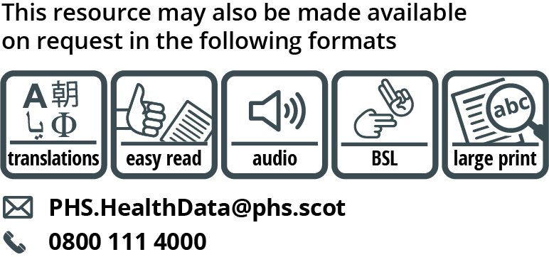

Use the subject line ‘translation request’ if you send an email. Include these details about the person who needs the different format:

- name
- address and postcode
- CHI number
- format or language required
Please tell us if we should always send information in this format. If you’ve asked for a translation before, it’s on its way to you.

The extra measures set out in this letter (and the table enclosed) which you are advised to follow to lower your risk of catching coronavirus count as “shielding measures” for the purposes of the Statutory Sick Pay (General) (Coronavirus Amendment) Regulations 2020

