|  |  |
| --- | --- |
|  |  |

|  |  |
| --- | --- |
| Directorate for Chief Medical Officer  Dr Gregor Smith  Interim Chief Medical Officer  St Andrews House | Regent Road | Edinburgh | EH1 3DG |  |

[**Patient Name**

Patient address Line 1

Patient address Line 2

Patient address Line 3]

21 December 2020

**IMPORTANT: PERSONAL**

**Your Community Health Index (CHI) number: [CHI NUMBER]**

**LIVING OR WORKING IN LEVEL 4 AREAS**

Dear [Patient],

As you may know, since November, local authority areas across Scotland have been placed into 5 Protection Levels: 0 - 4.

The First Minister has now announced that level 4 measures will be applied to all of mainland Scotland for a period of three weeks from one minute after midnight on Boxing Day morning. The exceptions to that will be Orkney, Shetland and the Western Isles, and the other island communities where restrictions have been reduced in recent weeks. These areas will go into level 3 but with strict restrictions on who can travel to and from them. All these levels will be reviewed after two weeks. You can find out what these areas are at [www.gov.scot/coronaviruslevels](http://www.gov.scot/coronaviruslevels).

For those of you who are living or working in an area at Level 4, we are asking you and everyone else to follow the advice very carefully. The general guidance for everyone in a Level 4 area can be found at [www.gov.scot/coronaviruslevel4](http://www.gov.scot/coronaviruslevel4). You can also get this information by calling the free National Assistance Helpline on 0800 111 4000 (Monday to Friday, 9am to 5pm).

As you are on the shielding list because you are at the highest risk of severe illness from coronavirus, we also have some extra advice for you to help protect you if you are living or working in a Level 4 area. This is set out in the table with this letter, and is also available online at www.mygov.scot/shielding. Please consider all of the advice in the table at Level 4 and think about what is right for you.

**If you are living in an area that moved into Level 4 before, you will already have received a letter which is similar to this letter. We are writing again now to everyone on the shielding list across all Protection Levels. This is because some of you may not live in an area at Level 4 but may need to travel to a Level 4 area for essential reasons such as work.**

This letter and the advice we set out will apply whenever an area is at Level 4. It is valid up to 31 March 2021. This does not mean areas will be in level 4 up to this date, but covers any changes in levels up to then. Please keep this letter safe. We suggest that you should continue to follow the extra advice[1] at each of the levels in the table.

**If you live or work in a Level 4 area**

We advise that you should not use public transport in a Level 4 area.

You should follow the general advice for everyone in Level 4 areas and work from home if you can. Employers should make sure their staff can work from home if possible.

If you cannot work from home, most workplaces can be made safe, even if you are at the highest risk. You should continue to follow the extra advice set out in the table while at work.

It is your employer’s responsibility to make your workplace and duties safe for you. This may include changing the way in which you work, to support you to follow the extra advice. Employees also have a responsibility to comply with safe working practices.

If you have any concerns you should discuss these with your manager or your employer. You can also get further advice from:

* Occupational Health services provided by your employer, where available
* a Health and Safety representative in your workplace
* your workplace’s Human Resources (HR) department
* your trade union or professional body

There is guidance for employers and employees on making the workplace safe at www.gov.scot/covid-workplace-risk. This includes a workplace risk assessment (COVID-Age) tool, [www.alama.shinyapps.io/Covid_Age](http://www.alama.shinyapps.io/Covid_Age) which you can use to show your employer your assessment of your personal risk. This can help you to discuss with your employer any additional adjustments or arrangements needed to make your workplace and duties safe for you.

**What to do if you can’t go to work**

Please note that being sent this letter does not automatically mean you need to stay off work. You should discuss how to make your workplace safe with your employer, so if possible you can continue to work while following the extra advice.

If your employer has done all they can and still can’t make your workplace and duties covid-safe for you, or, if you are unable to travel to work in a covid-safe way, you should not go to work for as long as the area in which you live or work is at Level 4.

If you cannot attend work because it is not covid-safe to do so, you will be able to use this letter as evidence for your employer to show that you should not go to work, including for statutory sick pay purposes. All you need to do is show them this letter, which serves a similiar purpose to a fit note, and is called your Shielding Notification. You do not need a separate fit note from your GP. Only stay off work if your workplace cannot be made covid-safe for you or if you cannot travel safely to work.

**Keep up to date with free text alerts**

If you have not already done so, please do consider joining the free text messaging service for people at highest risk from coronavirus. To join, send a text from your mobile phone with your Community Health Index (CHI) number to 07860 064525. Your CHI number is the 10-digit number at the top of this letter. We only need the number itself and, you do not need to text any other information.

You can also get information from the free National Assistance Helpline on 0800 111 4000 if you do not have access to a mobile phone.

Yours sincerely,

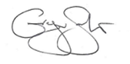

**DR GREGOR SMITH**

INTERIM CHIEF MEDICAL OFFICE



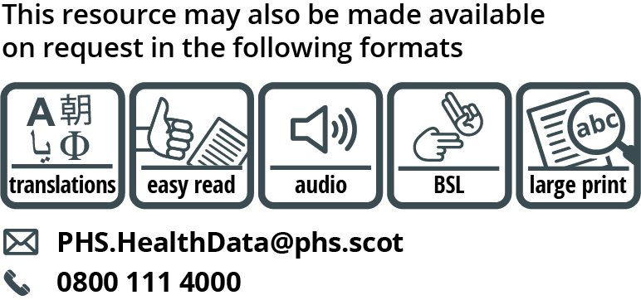

Use the subject line ‘translation request’ if you send an email. Include these details about the person who needs the different format:

* name
* address and postcode
* CHI number
* format or language required

Please tell us if we should always send information in this format. If you’ve asked for a translation before, it’s on its way to you.

1. The extra measures set out in this letter (and the table enclosed) which you are advised to follow to lower your risk of catching coronavirus count as “shielding measures” for the purposes of the Statutory Sick Pay (General) (Coronavirus Amendment) Regulations 2020