Directorate for Chief Medical Officer  Dr Gregor Smith  Interim Chief Medical Officer  St Andrews House | Regent Road | Edinburgh | EH1 3DG | 

[Patient Name
Patient address Line 1
Patient address Line 2
Patient address Line 3]
January 2021

IMPORTANT: PERSONAL

Your Community Health Index (CHI) number: [CHI NUMBER]

ADDITIONAL PROTECTIVE MEASURES
GOING TO SCHOOL, COLLEGE OR CHILDCARE

Dear [Patient],

The First Minister announced on Monday 4 January that there will be new additional protective measures from Tuesday 5 January for the whole of January for all parts of Scotland that were at level 4. These new restrictions and guidance are needed to curb and reverse the recent strong growth in transmission of the new coronavirus variant.

If you’re the parent or carer of the child or young person named at the top of this letter, this advice applies to that person. I wrote to you on 21 December to provide advice on going to school, college or childcare. This included a table of extra advice. I am writing to confirm that my extra advice for your child has not changed. The table is attached to this letter and can be found at www.mygov.scot/shielding. Please consider all of the advice in the table and think about what is right for you and your child.

I have changed my advice about going to work so if you are the person named at the top of this letter and are 16 or 17 and in work, please contact the National Assistance Helpline on 0800 111 4000 and we’ll arrange for a different letter to be sent to you. The advice on going to work has changed for the duration of the additional lockdown protection measures. We are now advising that for the duration of this lockdown and additional level of protection measures, if you cannot work from home, you should not attend work. You will need a separate letter from the Chief Medical Officer which applies to anyone under 18 who is working and advises that they don’t attend work if they cannot work from home.

As before, we are asking you, as the parent of a child or young person on the shielding list who is at the highest risk from coronavirus, to follow the same restrictions and advice as everyone else.

From Tuesday 5 January, a maximum of two people from up to two households will be able to meet outdoors. Children aged 11 and under will not be counted in that limit, and they will also be able to play outdoors in larger groups, including in organised gatherings. However, for everyone else – including 12 to 17 year olds - outdoor exercise should only take place in a way which is consistent with the 2 people from 2 households rule. There is more information at Coronavirus in Scotland - gov.scot (www.gov.scot).

Attending school, college or regulated childcare services
The First Minister previously indicated that the school holiday period will be extended to 11 January, and that arrangements for learning at home will be in place until 18 January. The First Minister has now announced that these arrangements are to be extended until 1 February and will be reviewed mid-January. This applies to all pupils, across the whole of Scotland, at nursery, primary and secondary schools, except for vulnerable children, and children of key workers.

At Level 4 and during this national lockdown with additional protective measures, our general advice is that children and young people who are on the shielding list should not attend school, college or regulated childcare services such as nurseries. However, you should consult your child’s secondary care (hospital) clinical team who may advise that an individualised risk assessment could be undertaken with the school, college or nursery and arrangements put in place which may allow your child to continue to attend when establishments re-open.

Arrangements for learning from home will be put in place for children and young people who cannot attend school or college in person due to shielding requirements. Your local education service will provide advice on the support available for children who are being asked not to attend school, college or childcare under additional protective measures or Level 4 rules.

We advise that you should not use public transport including taxis in a level 4 area or in an area under additional protective measures.

What this means as a parent or carer
If you are not attending your workplace due to the advice in this letter, which means that you should not go to work as you are caring for a child or young person who can’t go to childcare, school or college, your employer, at their discretion, may be able to furlough you through the Coronavirus Job Retention Scheme which has now been extended until April 2021. If you are furloughed, HMRC will give a grant to your employer to cover 80% of your normal salary, and your employer will need to pay National Insurance and pension contributions. I would encourage you to discuss this directly with your employer

Otherwise you may be eligible for Universal Credit, or other benefits, during this period. To find out further information about what benefits you may be entitled to, speak to your employer, or visit www.gov.uk/browse/benefits or contact Citizens Advice Scotland. Some employers may offer additional financial support for employees who are off work for caring or coronavirus-related reasons or caring purposes which may be set out in your terms and conditions of employment. To find out what financial support you will get, you should contact your employer. For more information and to claim, visit www.gov.uk/universal-credit, or call the Universal Credit helpline on 0800 328 5644.

The Job Retention Scheme does not apply if you are self-employed or to any income from self-employment. However, you may qualify for support under the Self-Employed Income Support Scheme. The online service for the thisgrant is available at www.gov.uk.

Informal Childcare
If you need other friends or family to help look after your child while you are at work, the people that help you should keep their contact with people from other households to a minimum, stringently follow the FACTS advice, and avoid sharing food and utensils. Whilst in the house, if possible, avoid touching hard surfaces but also regularly wipe surfaces down with anti-bacterial cleaner. Keep windows open and have fresh air flowing through the house, as much as possible.

Additional information, advice and support
As before, it is important to use family, friends, and neighbours for support. But if you need any additional advice, information, support or help, you can call the free National Assistance Helpline on 0800 111 4000 (Monday to Friday, 9am to 5pm). This will put you through to your local authority which can assess your needs and arrange additional support.

Keep up to date with text alerts
If you have not already done so, please do consider joining the free text messaging service for people at highest risk from coronavirus. To join, send a text from your mobile phone with your Community Health Index (CHI) number to 07860 064525. Your CHI number is the 10-digit number at the top of this letter. We only need the number itself. You can also get information from the free National Assistance Helpline on 0800 111 4000 if you do not have access to a mobile phone.

Yours sincerely,

DR GREGOR SMITH
INTERIM CHIEF MEDICAL OFFICER

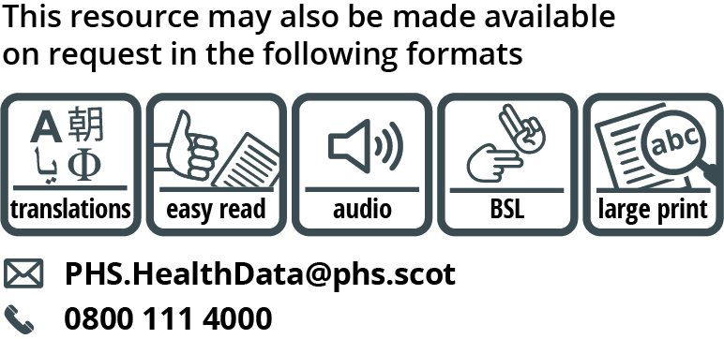

Use the subject line ‘translation request’ if you send an email. Include these details about the person who needs the different format:

- name
- address and postcode
- CHI number
- format or language required
Please tell us if we should always send information in this format. If you’ve asked for a translation before, it’s on its way to you.

