PCS software release document

PCS Scotland COVID19- Coronavirus vaccinations template

EMIS Health is pleased to announce a new template for the recording of Coronavirus vaccinations.

- COVID-19 - Coronavirus vaccinations

To use this template, you will need to copy the new COVID-19 – Coronavirus vaccinations template from the ‘EMIS Repository’ folder to your ‘Live templates’ folder.

Copying templates to your Live Templates folder
- From the main menu, click Template Designer in the Configuration section, or type TD.
- Select the EMIS Repository folder, and then select the Respiratory folder.
The updated template is displayed.
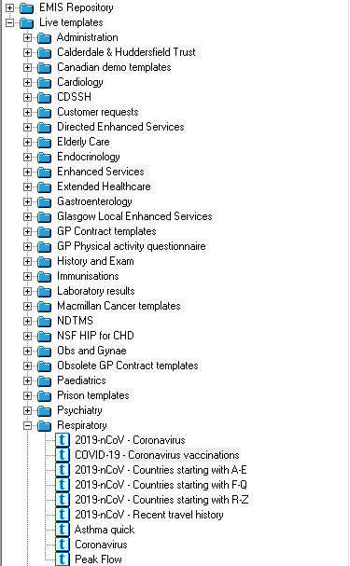
Template Designer, showing the COVID-19 coronavirus vaccinations template in the EMIS Repository, Respiratory folder

- Right-click the new template(s) and select Overwrite Live Template.
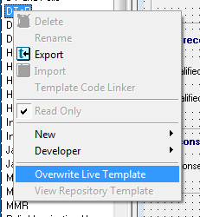
Overwrite Live Template option
Note: The template is displayed in both the EMIS Repository folder and the Live Templates folder. You can use and edit the templates from the Live Templates folder.

No part of this document may be sold, hired, reproduced or transmitted in any form or by any means, electronic or mechanical,
including photocopying, recording and information storage and retrieval systems for any other purpose than the purchaser’s use
without the express written permission of EMIS Health.
Every effort is made to ensure that your EMIS Health documentation is up to date, but our commitment to constantly improve our software and systems means that there may have been changes since this document was produced.
web: www.emishealth.com

