|  |  |
| --- | --- |
|  | 31 December 2021 |

|  |  |
| --- | --- |
| Directorate for Chief Medical Officer  Professor Gregor Smith  Chief Medical Officer  St Andrews House | Regent Road | Edinburgh | EH1 3DG |  |

**IMPORTANT: PERSONAL**

**Your Community Health Index (CHI) number: <<CHI>>**

Dear [forename] [surname],

Important information about new treatments for coronavirus (COVID-19)

The NHS is using new treatments for coronavirus (COVID-19). Your medical records show that you might be suitable for these treatments. These treatments may help if you develop COVID-19 symptoms and a PCR test confirms that you have the virus.

I am writing to you now because these treatments need to be given quickly after you start to experience COVID-19 symptoms. They may also stop you from getting seriously ill, so it is really important that we tell you in advance so you are prepared.

There is more information in this letter about what you need to do if you start to experience COVID-19 symptoms. Keep this letter somewhere safe so you can refer to it in the future.

While these treatments may help if you experience COVID-19 symptoms, it is important to remember that vaccination is still the best protection for you and your loved ones. If you haven’t already, please make sure you get both doses of the COVID-19 vaccine, and the third dose or booster as soon as you can.

Yours sincerely,

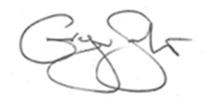

**PROFESSOR GREGOR SMITH**

CHIEF MEDICAL OFFICER

**Why we’ve sent you this letter**

Health experts have looked at the health conditions which put people more at risk from Covid-19. UK Chief Medical Officers agree about these conditions.

Your medical records show that you may have, or previously had, one or more of these health conditions. This means that these new treatments might be suitable for you if you experience COVID-19 symptoms and a PCR test confirms you have COVID-19. You can find out how the NHS has used your information to identify and contact you about this treatment at [www.informationgovernance.scot.nhs.uk/covid-19-privacy-statement](http://www.informationgovernance.scot.nhs.uk/covid-19-privacy-statement)

**If you start to experience COVID-19 symptoms**

If you start experiencing symptoms of coronavirus (COVID-19), you should self-isolate immediately and book a test as soon as possible.

The most common symptoms of COVID-19 are:

* A new continuous cough
* fever/high temperature (37.8C or greater)
* loss of, or change in, sense of smell or taste (anosmia)

The following are also considered symptoms of COVID-19: chills, sore throat, shortness of breath or difficulty breathing, nausea, vomiting, diarrhoea, headache, red or watery eyes, body aches, fatigue, loss of appetite, confusion, dizziness, pressure or tight chest, chest pain, stomach ache, rash, sneezing, sputum or phlegm, runny nose.

**Booking a PCR test**

The fastest testing route is to visit a testing site however if you know that this will not be possible for you, you can request a home test kit to have ready at home in case you start to experience symptoms.

More information about arranging a test is available by phoning 119 or visiting: [www.nhsinform.scot/testing-symptoms](http://www.nhsinform.scot/testing-symptoms)

There are alternative testing arrangements in place for some island and highland areas; you can use the ‘get a coronavirus test’ guide on NHS Inform at the link above to find out how to access a test in your area.

**Priority PCR testing**

In Scotland, essential workers who cannot work from home, people on the highest risk list, and those who are eligible for new COVID treatments, will be prioritised for PCR testing in periods of high demand and, if asked, should tick they are an essential worker when booking a test to get a priority PCR test (example below).

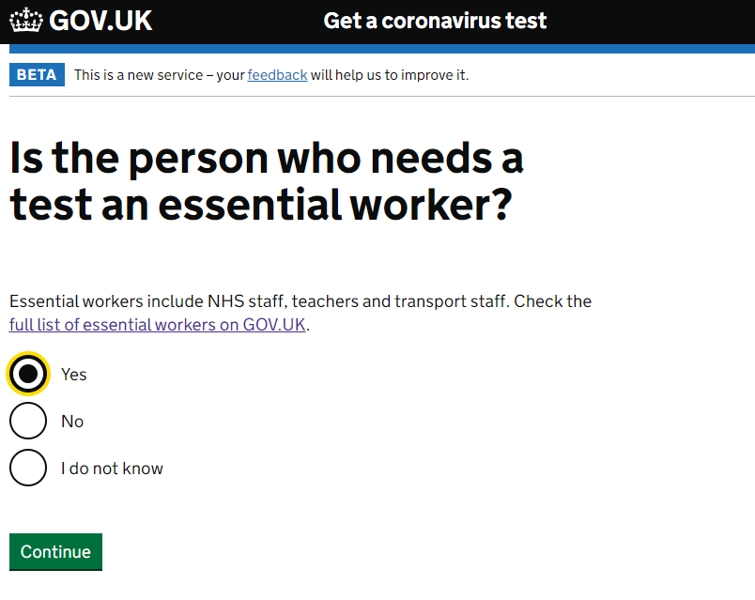

**Contact your health board as soon as you test positive**

If you test positive for COVID-19, you may be eligible for one of the new COVID-19 treatments. If you would like to be assessed for your suitability for treatment, then you should contact your health board as soon as you get a positive test. Use this number: XXXX XXXXXX. Lines will be open 7 days a week. An answering machine and call-back service may be in use so do not use this number if you are seeking urgent medical advice or have a general health query.

If treatment is available and you are assessed as being eligible, you might have to travel to a day clinic at a hospital. You'll get instructions on where to get the treatment and how to get there and back safely. You’ll then receive a treatment called a monoclonal antibody treatment. This is normally given by intravenous infusion (in your vein). However, your clinician may recommend an antiviral treatment to be taken orally instead.

Coronavirus is much less likely to progress to severe disease in people aged 12 - 17 even in those who might be viewed as at increased risk. Only those 12 - 17 year olds assessed as at exceptionally high risk will be offered an infusion of a monoclonal antibody treatment. The oral antiviral treatment (molnupiravir) is only authorised for use in adults over 18.

More information is available at [www.nhsinform.scot/covid19treatments](http://www.nhsinform.scot/covid19treatments)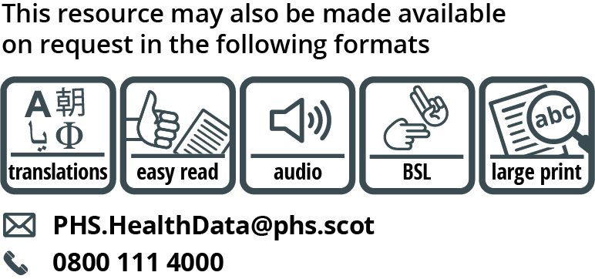

Use the subject line ‘translation request’ if you send an email. Include these details about the person who needs the different format:

* name
* address and postcode
* CHI number
* format or language required

Please tell us if we should always send information in this format. If you’ve asked before for a translation of the information we send, it’s on its way to you.

**Data Protection Statement**

You have been identified from either your GP practice, local Health Board or securely stored national data in order that we could write to you. We want to reassure you that this information has only been shared in a limited way within the NHS in Scotland. We will notify your Health Board that you have been contacted in order that they can provide appropriate support.