
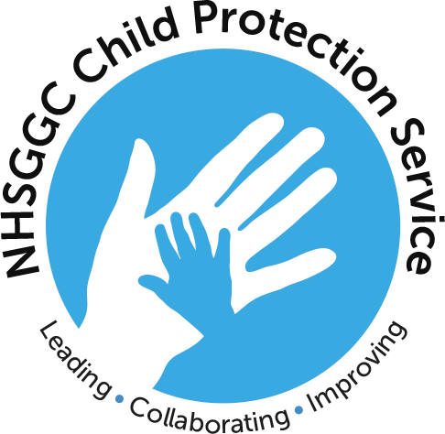

CHILD PROTECTION LEVEL 3 YOUR ROLES & RESPONSIBILITIES
LEARNING & EDUCATION TRAINING SESSIONS 2022

Please note that all training sessions will be delivered remotely via MS Teams and can be booked by accessing the on-line catalogue via e-ESS https://eess.mhs.scot.nhs.uk/

Thursday 20th January 2022 10am – 12pm
Thursday 17th February 2022 2pm – 4pm
Thursday March 17th 2022 10am – 12pm
Thursday 14th April 2022 2pm – 4pm
Thursday 12th May 2022 10am – 12pm
Thursday 9th June 2022 2pm – 4pm
Thursday 7th July 2022 10am – 12pm
Thursday 4th August 2022 2pm – 4pm
Thursday 1st September 2022 10am – 12pm
Tuesday 4th October 2022 2pm – 4pm
Tuesday 1st November 2022 10am – 12pm
Tuesday 6th December 2022 2pm – 4pm

All participants will require access to a digital device e.g. laptop or phone to join the training session and an MS Teams link will be sent directly to you following successful enrolment on the training session.

*Please Note - It is your responsibility to ensure that your email address and contact details on e-ESS are up-to-date otherwise the system will not allocate you a place on the training session*

