 | 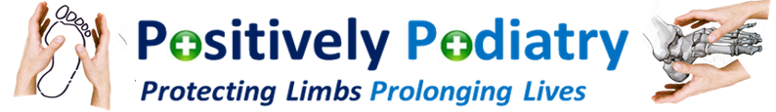
Purpose of Paper: |  | For Distribution
Classification: |  | HSCP COs, GPs,
Sponsoring CO/Manager: |  | David Leese, Chief Officer Renfrewshire HSCP  (Hosting Partnership for NHSGG&C Podiatry Service)

Paper Title

NHSGG&C Podiatry Service Recovery plan

What happened in Podiatry during COVID19?

During COVID, Podiatry services have been treating foot wounds, foot infections and individuals at known risk of tissue breakdown. These services have been limited to 17 bases across the NHS Board area, and have also involved an increased number of home visits.

What is happening next in Podiatry?

Following agreement at NHSGG&C Board’s SEG, podiatry is now ready to move to the first stage of service recovery for new referrals and existing patients.

NEW REFERRALS

New referrals will be accepted from 3 August 2020, and appointed initially into a telephone appointment to establish clinical need.

From there they will be either discharged with advice, offered a NearMe appointment or put on the waiting list for a face to face appointment.

Additional New Patient clinics will be running at QEUH Podiatry Department, including evening and Saturday sessions from 27 July 2020.

EXISTING PATIENTS

The historic caseload of podiatry patients has been divided up into 4 tranches of clinical need.

The first tranche of patients will be sent appointments to return to the service at one of the 17 bases already in operation from week commencing 3 August 2020. This will enable the service to accommodate an additional 2,500 appointments.

Further phases of recovery will be implemented in line with the proposed timetable, each phase bringing back a further tranche of patients based on historic clinical need.

These proposals are portrayed visually in the attached infographs for ease of reference. Should you require any further information please contact: David Wylie on 07813 343007.

David Leese David Wylie
Chief Officer, Renfrewshire HSCP Head of Podiatry, NHSGG&C

