Updating your Username in Community Learnpro
All GP Practice Staff have now migrated to their new nhs.scot email accounts. If you used your nhs.net email address as your username for Community Learnpro, it will still work, but if Learnpro send you any notifications, such as password changes, you will no longer receive them. To change your nhs.net username to your new nhs.scot one, or another email address please follow this procedure.
Log into Community Learnpro, and click on the “PROFILE” tab in your account.
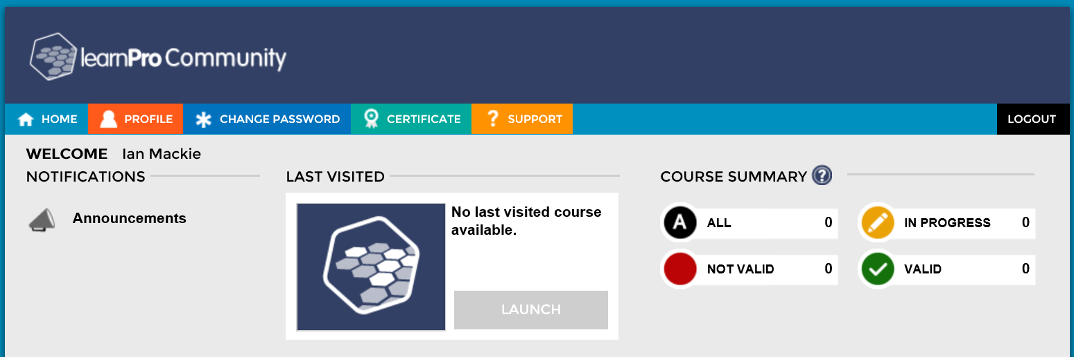
On the profile tab change your Email/Username to your new one and click on Update Changes
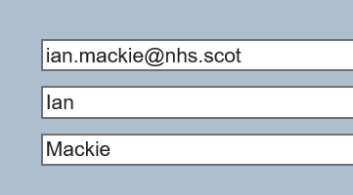
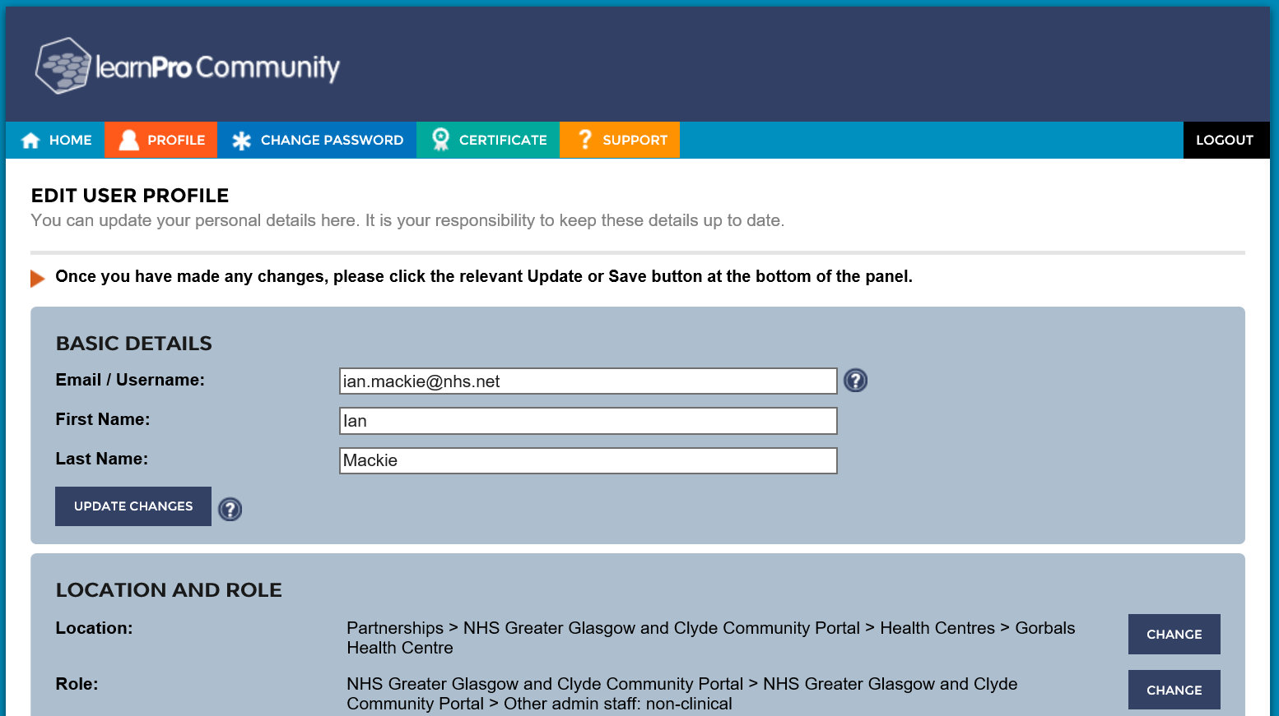
You have now changed your username, your password should remain unchanged. Now logout of Community Learnpro and login using your new username.
If you have any problems with this drop Ian Mackie an email at ian.mackie@ggc.scot.nhs.uk.

