Directorate for Chief Medical Officer  Dr Gregor Smith  Interim Chief Medical Officer  St Andrews House | Regent Road | Edinburgh | EH1 3DG | 

[Patient Name
Patient address Line 1
Patient address Line 2
Patient address Line 3]
19 November 2020

IMPORTANT: PERSONAL

Your Community Health Index (CHI) number: [CHI NUMBER]

LEVEL 4 RESTRICTIONS FROM 6PM 20 NOVEMBER

Dear [Patient],

As you may know from the First Minister’s announcement on 17 November, your local authority area has been placed into Protection Level 4. We are asking you and everyone else in your area to follow the advice very carefully. The general guidance for everyone in a Level 4 area can be found at www.gov.scot/coronaviruslevel4. You can also get this information by calling the free National Assistance Helpline on 0800 111 4000 (Monday to Friday, 9am to 5pm)
We also have some extra advice for people like you, who are at the highest risk of severe illness from coronavirus to help protect you while your area is in Level 4. This is set out in the table with this letter, and is also available online at www.gov.scot/coronavirus. Please consider all of the advice in the table at Level 4 and think about what is right for you.

Working if you’re in Level 4
You should follow the general advice for everyone in Level 4 areas and work from home if you can. Employers should make sure their staff can work from home if possible.

If you cannot work from home, most workplaces can be made safe, even if you are at the highest risk. You should continue to follow the extra advice set out in the table while at work.

It is your employer’s responsibility to make your workplace and duties safe for you. This may include changing the way in which you work, to support you to follow the extra advice. Employees also have a responsibility to comply with safe working practices.

If you have any concerns you should discuss these with your manager or your employer. You can also get further advice from:
- Occupational Health services provided by your employer, where available
- a Health and Safety representative in your workplace
- your workplace’s Human Resources (HR) department
- your trade union or professional body

There is guidance for employers and employees on making the workplace safe at www.gov.scot/covid-workplace-risk. This includes a workplace risk assessment (COVID-Age) tool, www.alama.shinyapps.io/Covid_Age which you can use to show your employer your assessment of your personal risk. This can help you to discuss with your employer any additional adjustments or arrangements needed to make your workplace and duties safe for you.

What to do if you can’t go to work
Please note that being sent this letter does not automatically mean you need to stay off work. You should discuss how to make your workplace safe with your employer, so you can continue to work.

If your employer has done all they can and still can’t make your workplace and duties covid-safe for you, you can use this letter as evidence that you cannot go to work for as long as your area is at level 4. All you need to do is show them this letter, which serves as a fit note, and is called your Shielding Notification. You do not need a separate fit note from your GP. Only stay off work if your workplace cannot be made covid-safe for you or if you cannot travel safely to work.

Keep up to date with free text alerts
If you have not already done so, please do consider joining the free text messaging service for people at highest risk from coronavirus. To join, send a text from your mobile phone with your Community Health Index (CHI) number to 07860 064525. Your CHI number is the 10-digit number at the top of this letter. We only need the number itself and, you do not need to text any other information.

You can also get information from the free National Assistance Helpline on 0800 111 4000 if you do not have access to a mobile phone.

Yours sincerely,

DR GREGOR SMITH
INTERIM CHIEF MEDICAL OFFICER

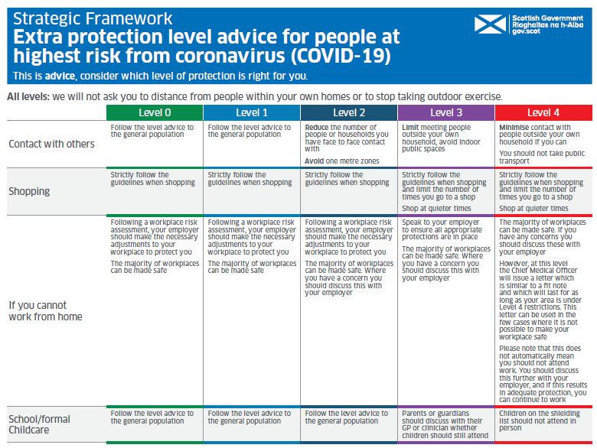
How to request this information in a different format

Other formats of this information may be available on request. If you or someone you know needs this in a different format or language, email phs.healthdata@phs.scot. Use the subject line ‘translation request’.

Please include these details about the person who needs the different format:

- name
- address and postcode
- CHI number
- format or language required

Please also tell us if we should send information in this format in future. You can also call the national helpline on 0800 111 4000 with this information. It’s open Monday to Friday, from 9am to 5pm.

If you’ve already asked for the information we send to you to be translated, it will be on its way to you.
Update for BSL

