Directorate for Chief Medical Officer  Dr Gregor Smith  Interim Chief Medical Officer  St Andrews House | Regent Road | Edinburgh | EH1 3DG | 

[Patient Name
Patient address Line 1
Patient address Line 2
Patient address Line 3]
19 November 2020

IMPORTANT: PERSONAL

Your Community Health Index (CHI) number: [CHI NUMBER]

Your Area is in Protection Level 4 from 6pm on 20 November

Dear [Patient],

As you may know from the First Minister’s announcement on 17 November, your local area has been placed into Protection Level 4. We are asking you and everyone in your area to follow the Level 4 rules carefully. The general guidance for everyone in a Level 4 area can be found at www.mygov.scot. You can also call the free National Assistance Helpline on 0800 111 4000 (Monday to Friday, 9am to 5pm).
We also have extra advice for people at the highest risk of severe illness from coronavirus. This is set out in the table with this letter, and is also available online at www.mygov.scot. Please do think about all of the advice in the table at Level 4 and whether you would like your child to follow it.

If you’re the parent or carer of the child or young person named at the top of this letter, this advice applies to that person. If you are the person named at the top of this letter and are 16 or 17 and in work, please contact the National Assistance Helpline on 0800 111 4000 and we’ll arrange for a different letter to be sent to you.

Attending school, college or regulated childcare services
At Level 4, our general advice is that children and young people who are on the shielding list should not attend school, college or regulated childcare services such as nurseries. However, you should consult your child’s secondary care (hospital) clinical team who may advise that an individualised risk assessment could be undertaken with the school, college or nursery and arrangements put in place which may allow your child to continue to attend.

Arrangements for learning from home will be put in place for children and young people who cannot attend school or college in person due to shielding requirements. Your local education service will provide advice on the support available for children who are being asked not to attend school, college or childcare under Level 4 rules.

What this means as a parent or carer
Level 4 rules may mean you cannot attend your workplace or work at home because you have to care for a child or young person on the shielding list. If this is the case, you may be eligible to be furloughed under the Job Retention Scheme. Decisions around whether to offer you a furlough agreement are down to your employer. If you’re on furlough, you’ll still be paid by your employer, and will pay taxes from your income.Your employer could pay 80% of your regular wages up to a monthly cap of £2500. They might choose to pay you more from their own accounts. You should discuss this option with your employer and check the eligibility criteria at www.gov.uk.

If being on furlough reduces your income, you may be eligible for Universal Credit. If you already receive benefits, you can have your Universal Credit payments reassessed. For more information and to claim, visit www.gov.uk/universal-credit, or call the Universal Credit helpline on 0800 328 5644.

If you were contracted to work less than 16 hours per week before you were placed on furlough, you may be eligible for New Style Jobseeker’s Allowance (JSA). To find out more and apply, go to www.gov.uk/guidance/new-style-jobseekers-allowance or call Jobcentre Plus on 0800 055 6688

The Job Retention Scheme does not apply if you are self-employed or to any income from self-employment. However, you may qualify for support under the Self-Employed Income Support Scheme. The online service for the next grant will be available at www.gov.uk from 30 November.

Informal Childcare
If you need other friends or family to help look after your child while you are at work, the people that help you should keep their contact with people from other households to a minimum, stringently follow the FACTS advice, and avoid sharing food and utensils. Whilst in the house, if possible, avoid touching hard surfaces but also regularly wipe surfaces down with anti-bacterial cleaner. Keep windows open and have fresh air flowing through the house, as much as possible.

Keep up to date with text alerts
If you have not already done so, please do consider joining the free text messaging service for people at highest risk from coronavirus. To join, send a text from your mobile phone with your Community Health Index (CHI) number to 07860 064525. Your CHI number is the 10-digit number at the top of this letter. We only need the number itself. You can also get information from the free National Assistance Helpline on 0800 111 4000 if you do not have access to a mobile phone.

Yours sincerely,

DR GREGOR SMITH
INTERIM CHIEF MEDICAL OFFICER

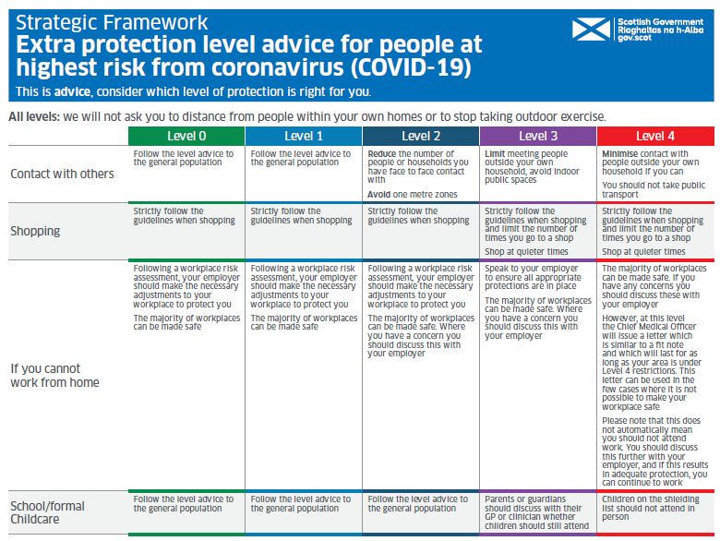

How to request this information in a different format
b
Other formats of this information may be available on request. If you or someone you know needs this in a different format or language, email phs.healthdata@phs.scot. Use the subject line ‘translation request’.

Please include these details about the person who needs the different format:

- name
- address and postcode
- CHI number
- format or language required

Please also tell us if we should send information in this format in future. You can also call the national helpline on 0800 111 4000 with this information. It’s open Monday to Friday, from 9am to 5pm.

If you’ve already asked for the information we send to you to be translated, it will be on its way to you.

