Level 4 restrictions and shopping safely

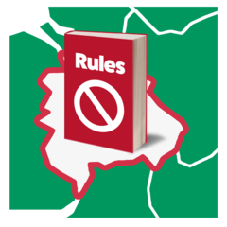 | This is an Easy Read version of a letter sent to people who live in a level 4 area and have a high chance of becoming very ill from the coronavirus.  This is sometimes called the shielding list.
You can read more about what level 4 of the coronavirus means here
www.gov.scot/coronaviruslevel4
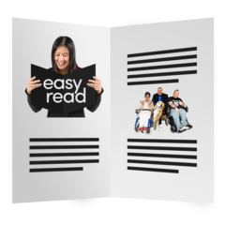 | Easy read information on the levels can be found at the end of this easy read.
 | We are sending you this easy read to give you extra advice that should help you.
 | People in level 4 areas should work from home
 | If you cannot work from home then speak to your boss about making workplace safer.
You can find more information about this here
www.gov.scot/covid-workplace-risk
 | If you definitely cannot go to work you can use the letter as evidence. This is called a fit note.
 | You do not need a fit note from your GP.
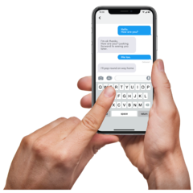 | You might like to get text messages with more information about staying safe
 | Send a text from your mobile phone with your Community Health Index (CHI) number to 07860 064525. Your CHI number is the 10-digit number at the top of your letter.
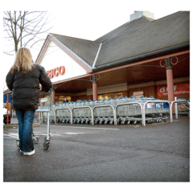 | The rest of this easy read is information about supermarket shopping.
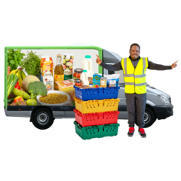 | People on the shielding list can get special slots for online delivery from supermarkets.
 | There is also some information about how to shop safely if you go into the shop.

Priority access to supermarket online delivery slots
 | Some supermarkets have agreed to give people who are on the shielding list a better chance of getting online grocery delivery slots. A delivery slot is the time when they deliver your shopping.
 | If you or your child or someone else you look after is on the shielding list you can sign up for this service.
 | The supermarkets that give this service are Asda, Tesco, Morrisons, Sainsbury’s, Iceland and Waitrose.
 | If you sign up for the service the Scottish Government will send them the information to show that you are on the shielding list.
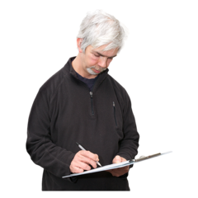 | You need to register to be able to get the priority delivery slots.

How to register for a priority online delivery slot by text message

 | If you have not registered yet you can do it now.
 | You need to use the name of the person who is on the shielding list.
That means if you are on the list use your name.
If your child is on the list use their name or if you are a carer for someone who is on the list use their name.

 | To sign up using text you need to be on the Scottish Government’s shielding text service.
 | If you are not on the text service join by texting your CHI number to 07860 064525
 | You will see your CHI number at the top of the letter with this Easy Read or another letter from the NHS
 | After you have joined the shielding text service send a text saying 1SHOP to 07860 064525 from your mobile.
 | If you already have an online account with one of the supermarkets in the list below they will send you an email with instructions.
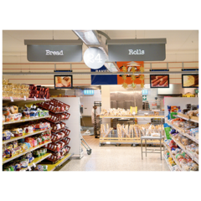 | The supermarkets which are taking part in this are Asda, Tesco, Morrisons, Sainsbury’s, Iceland and Waitrose.
 | They will use the email address you used when you made your account with the supermarket.
 | If you do not get an email check your junk mail box.

What to do if you have not already got an account with one of the online supermarkets

 | After you have sent a text to register for the priority shopping service you will get a text from GOV.SCOT
 | The text you get back will tell you how to register with the supermarket.
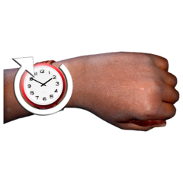 | You might still need to wait a while to get a delivery slot.
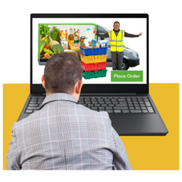 | You might need to try a different supermarket to get a slot at a time that you want.

How to register for a priority online delivery slot by phone

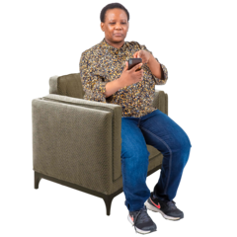 | You can phone the free number Monday to Friday between 9 and 5
 | The number is 0800 111 4000
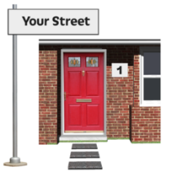 | You will need to tell the staff your name, address and CHI number.
 | You will find your CHI number at the top of the letter with this Easy Read or a letter from the NHS.
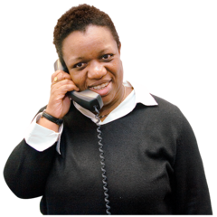 | A friend or carer can call for you if you cannot call yourself.

Shopping in store
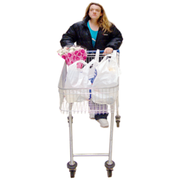 | If you go to the shops yourself or someone else there are some things you can do to help to keep safe.
 | Try to go to the shops less often.
 | Go to the shops when they are quieter.
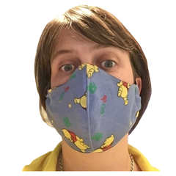 | Put on your face covering before you touch the baskets or trolleys.
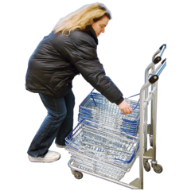 | Clean the handles of the basket or trolley before you touch them.
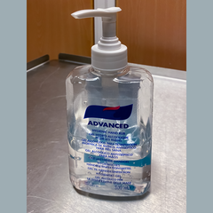 | Use hand sanitiser when you arrive and when you leave.
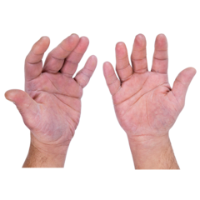 | Try not to touch the shop doors with your hands.
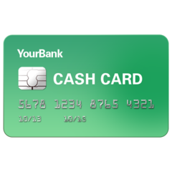 | Pay using contactless payments if you can.

What supermarkets and shops are doing to make things safer
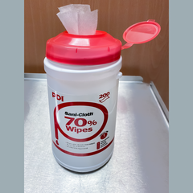 | Most shops now have areas where you can clean your hands, trolleys and baskets.
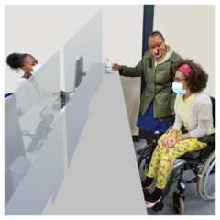 | There are safety screens at check outs.
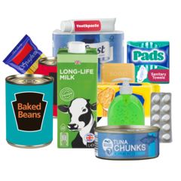 | Shops have more self-service tills.
 | More things can be paid for using contactless now.
 | Some shops have put in special times for people who need more help.
 | There is help available for people to do shopping for you.

How to get organised
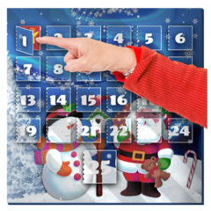 | Shops can be busy when we get closer to Christmas.
 | If you can it is a good idea to be organised and to try to get the things you need from the shops early.
 | If you need more information or support to get food and other essentials there is a free number you can phone.
 | You or someone who cares for you can phone the number for help.
 | The number is 0800 111 4000
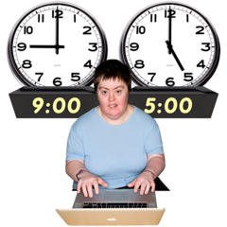 | You can call the number Monday to Friday 9 till 5
 | There is more information on the Scottish Government Website
 | This is the link to the page on the website. mygov/shielding

Easy read information on levels
Level 0
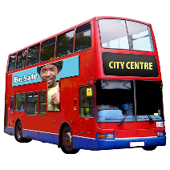  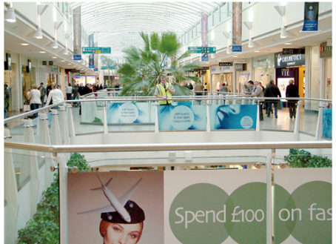  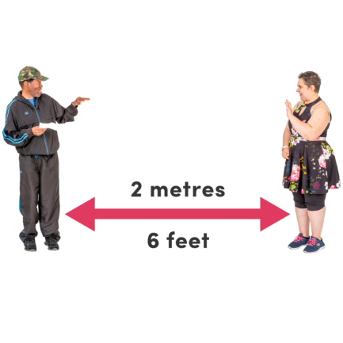 | A maximum of 8 people from 3 different households can meet indoors.  A maximum of 15 people from 5 different households can meet outdoors.  Carers and support workers can make home visits.  You should avoid non-essential travel to areas that are in Level 3 and 4.  Avoid car sharing.  Shops, leisure and entertainment venues are open, but not nightclubs.  Weddings, receptions, funerals and wakes are limited to 50 people.  Social distancing and face covering rules still apply in all of the levels.
Level 1
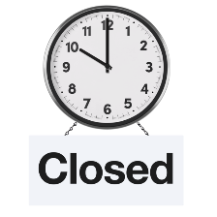 | People from different households are not allowed to meet indoors in each other’s house. This might change and guidance will be updated.  Carers and support workers can make home visits.  A maximum of 6 people from two different households can meet outdoors or in cafes, pubs and restaurants.  Pubs and restaurants may only be open at certain times.  Weddings, receptions, funerals and wakes are limited to 20 people.  You should avoid non-essential travel to areas that are in Level 3 and 4.  Avoid car sharing.  All sports and exercises are allowed but not indoor contact sports for adults.
Level 2
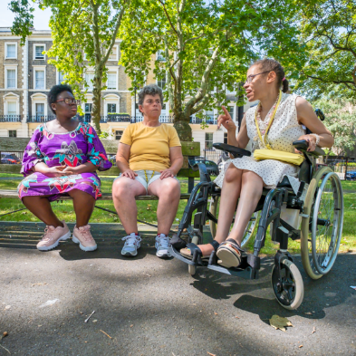 | People from different households are not allowed to meet indoors in each other’s house.  Carers and support workers can make home visits.  A maximum of 6 people from 2 different households can meet outdoors or in cafes, pubs and restaurants.  You should avoid non-essential travel to areas that are in Level 3 and 4.  Avoid car sharing.  Most leisure and entertainment venues are closed except cinemas, amusement arcades, and bingo hall
Level 3
People from different households are not allowed to meet indoors in each other’s house.

Carers and support workers can make home visits.

A maximum of 6 people from 2 different households can meet outdoors or in cafes, pubs and restaurants.

No non-essential travel into or out of the Level 3 area.
Avoid non-essential use of public transport.

Avoid car sharing.

Level 4
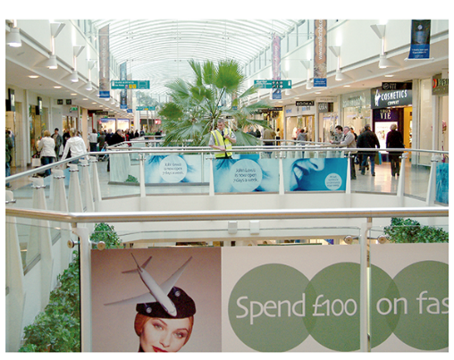  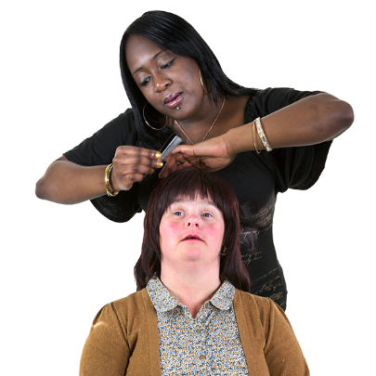  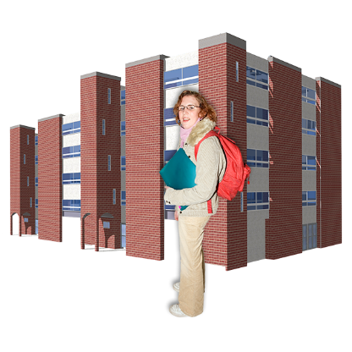 | People from different households are not allowed to meet indoors in each other’s house.  Essential visits of carers and support workers are allowed.  A maximum of 6 people from two different households can meet outdoors and in public places.  No non-essential travel into or out of the Level 4 area.  No use of public transport unless for essential purposes.  Non-essential shops are closed.  Hotels, B&Bs and self-catering only used for essential accommodation.  Hairdressers, tailors, barbers and beauticians are closed.  Gyms are closed and only non-contact sports allowed outdoors.  All leisure, entertainment and visitor attractions are closed.  Weddings limited to 15 people. Funerals and wakes are limited to 20 people. Receptions are not allowed.  Schools remain open, but there are stricter rules on teaching at university and college.

Please note this is only a summary document.

It does not list all the restrictions under every level.
https://www.gov.scot/publications/coronavirus-covid-19-protection-levels/

Copyright images © Photosymbols.
Easy read information prepared by SCLD People First (Scotland).

